**MINISTRY OF EDUCATION AND TRAINING**

**FPT UNIVERSITY**

Capstone Project Report 4

**Building the laboratory tests management system**

|  |  |
| --- | --- |
| **Group 6** | |
| **Group members** | Bạch Minh Đức – SE61791  Châu Minh Ý– SE61419  Trần Tuấn Dũng – SE61982  Nguyễn Hữu Lâm – SE61234 |
| **Supervisor** | Hồ Hoàn Kiếm |
| **Ext. Supervisor** | N/A |
| **Capstone Project Code** | eLTMS |

- Ho Chi Minh City, 14 September 2018 -

# Table of Contents

Table of Contents 2

List of Tables 4

List of Figures 4

Software Design Description 7

1. Design Overview 7

2. System Architectural Design 7

3. Component Diagram 9

4. Details Description 10

4.1. Class Diagram 10

4.2. Class Diagram Explanation 11

4.2.1. User 11

4.2.2. Admin 12

4.2.3. Personal member 12

4.2.4. Role 12

4.2.5. UserRole 12

4.2.6. Address 13

4.2.7. Item 13

4.2.8. Auction 13

4.2.9. Category 14

4.2.10. Media 14

4.2.11. Bid 14

4.2.12. MinIncrementRule 15

4.3. Interactive Diagram 15

4.3.1. Guest 15

4.3.1.1. Login 15

4.3.1.2. Register account 15

4.3.1.3. Search Auctions 16

4.3.1.4. View Auction Details 16

4.3.1.5. View Suggested Auctions 17

4.3.2. Administrator 17

4.3.2.1. Accept Auction 17

4.3.2.2. Reject Auction 18

4.3.2.3. Search Users 18

4.3.2.1. Activate User 19

4.3.2.2. Restrict User 19

4.3.3. Auctioneer 20

4.3.3.1. Submit Auction 20

4.3.4. Bidder 21

4.3.4.1. Place Bid 21

4.3.5. Auctioneer & Bidder 21

4.3.5.1. View Auction History 21

4.3.5.2. Register address 22

4.3.5.3. View Contact Information 22

4.4. State Machine Diagram 23

5. User Interface Design 24

5.1. Web admin application user interface 24

5.1.1. Login 24

5.1.2. View Dashboard 25

5.1.3. View User Management Page 26

5.1.4. View Pending Auctions 27

5.1.5. View List Auctions 28

5.1. Web application user interface 29

5.1.1. Login/Register 29

5.1.2. Nav Bar 32

5.1.3. Home Page - List of auctions 32

5.1.4. Submit Auction 34

5.1.5. Search auctions by category 35

5.1.6. Bidding History 38

5.1.7. Selling History 40

5.1.8. Auction Details 42

5.1.9. Search By Keyword Result 45

5.1.10. Register address 46

5.2. Mobile application user interface 47

5.2.1. Opening Page 47

5.2.2. Login page 48

5.2.3. Update Address 49

5.2.4. Register Account page 50

5.2.5. Home page 51

5.2.6. Auction Detailss Page 52

5.2.7. Personal page 53

5.2.8. Bidding History page 55

5.2.9. Selling History page 56

5.2.10. Submit Auction page 56

5.2.11. Category page 58

5.2.12. Item By Category page 59

5.2.13. Search page 60

6. Database Design 62

6.1. Entity relationship diagram (ERD) 62

6.2. Entity dictionary 62

7. Algorithms 64

7.1. Automatic bidding 64

7.1.1. Definition 64

7.1.2. Define problem 64

7.1.3. Solution 64

7.1.4. Complexity 65

7.1.5. Example 65

7.2. Auction’s Time Remaining Consistency Among Clients 65

7.2.1. Define problem 65

7.2.2. Solution 65

7.2.3. Complexity 65

7.3. Auction suggestion based on the one that user is currently viewing 65

7.3.1. Define problem 65

7.3.2. Solution 65

7.3.3. Complexity 65

7.3.4. Example 65

# List of Tables

Table 1 - Component Dictionary 10

Table 2 - Class Dictionary 11

Table 3 - Class Diagram Explanation <User> 11

Table 4 - Class Diagram Explanation <Admin> 12

Table 5 - Class Diagram Explanation <Personal member> 12

Table 6 - Class Diagram Explanation <Role> 12

Table 7 - Class Diagram Explanation <UserRole> 12

Table 8 - Class Diagram Explanation <Address> 13

Table 9 - Class Diagram Explanation <Item> 13

Table 10 - Class Diagram Explanation <Auction> 14

Table 11 - Class Diagram Explanation <Media> 14

Table 12 - Class Diagram Explanation <Bid> 14

Table 13 - Class Diagram Explanation <MinIncrementRule> 15

Table 14 - Entity dictionary 63

Table 15 - Bid Incremement 64

Table 16 - Example table for viewing history 65

Table 17 - Example table for affinity score 66

# List of Figures

Figure 1 - System Architecture Design 7

Figure 2 - Component Diagram 9

Figure 3 - Class Diagram 10

Figure 4 - Sequence Diagram for Login < Guest > 15

Figure 5 - Sequence Diagram for Register Account < Guest > 16

Figure 6 - Sequence Diagram for Search Auctions < Guest > 16

Figure 7 - Sequence Diagram for View Auction Details < Guest > 17

Figure 8 - Sequence Diagram for View Suggested Auctions < Guest > 17

Figure 9 - Sequence Diagram for Accept Auction < Administrator > 18

Figure 10 - Sequence Diagram for Reject Auction < Administrator > 18

Figure 11 - Sequence Diagram for Search Users < Administrator > 19

Figure 12 - Sequence Diagram for Activate User < Administrator > 19

Figure 13 - Sequence Diagram for Restrict User < Administrator > 20

Figure 14 - Sequence Diagram for Submit Auction < Auctioneer > 20

Figure 15 - Sequence Diagram for Place Bid < Bidder > 21

Figure 16 - Sequence Diagram for View Auction History < Auctioneer/Bidder > 22

Figure 17 - Sequence Diagram for Register Address < Auctioneer/Bidder > 22

Figure 18 - Sequence Diagram for View Contact Information` < Auctioneer/Bidder > 23

Figure 19 - State Machine Diagram of Auction 23

Figure 20 - Admin Web Interface <Login> 24

Figure 21 - Admin Web Interface <View Dashboard> 25

Figure 22 - Admin Web Interface <View User Management Page> 26

Figure 23 - Admin Web Interface <View Pending Auctions> 27

Figure 24 - Admin Web Interface <View List Auctions> 28

Figure 25 - Web Interface <Login/Register/Search> 29

Figure 26 - Web Interface <Login Popup> 29

Figure 27 - Web Interface <Register account> 31

Figure 28 - Web Interface <Menu bar and Categories> 32

Figure 29 - Web Interface <Home page - Newly listed auctions> 32

Figure 30 - Web Interface <Home page - Ending soon auctions> 33

Figure 31 - Web Interface <Home page - Highest number of bids > 33

Figure 32 - Web Interface <Home page - Recently viewed auctions > 34

Figure 33 - Web Interface <Submit Auction> 34

Figure 34 - Web Interface <Dropdown list of categories> 36

Figure 35 - Web Interface <Auctions By Category> 36

Figure 36 - Web Interface < Categories bar and sort> 37

Figure 37 - Web Interface <Bidding Auctions History> 38

Figure 38 - Web Interface <Won Auctions History> 38

Figure 39 - Web Interface <Lost Auctions History> 39

Figure 40 - Web Interface <Contact Seller> 39

Figure 41 - Web Interface <Active Auctions History> 40

Figure 42 - Web Interface <Ended Auctions History> 40

Figure 43 - Web Interface <Rejected Auctions History> 40

Figure 44 - Web Interface <Pending Auctions History> 41

Figure 45 - Web Interface <Contact Bidder> 41

Figure 46 - Web Interface <Auction Details> 42

Figure 47 - Web Interface <Confirm to place bid> 43

Figure 48 - Web Interface <Bidding History> 44

Figure 49 - Web Interface <Recommended Auctions> 44

Figure 50 - Web Interface <Search By Keyword Result> 45

Figure 51 - Web Interface <Register address> 46

Figure 52 - Mobile Interface <Opening> 47

Figure 53 - Mobile Interface <Login> 48

Figure 54 - Mobile Interface < Update address> 49

Figure 55 - Mobile Interface <Register account> 50

Figure 56 - Mobile Interface <Home> 51

Figure 57 - Mobile Interface <Auction Details> 52

Figure 58 - Mobile Interface <Personal> 53

Figure 59 - Mobile Interface <Selling> interface 54

Figure 60 - Mobile Interface <Bidding History> 55

Figure 61 - Mobile Interface <Auction Submit> 56

Figure 62 - Mobile Interface <Choose image> 57

Figure 63 - Mobile Interface <Category> 58

Figure 64 - Mobile Interface <Item by category> 59

Figure 65 - Mobile Interface <Search> 60

Figure 66 - Mobile Interface <Search result> 61

Figure 67 - Entity relationship diagram (ERD) 62

# **Software Design Description**

## **Design Overview**

This document describes the technical and user interface design of Building the laboratory tests management system (eLTMS).

Document overview:

Section 2: gives an overall description of the system architecture design.

Section 3: gives component diagrams that describe the connection and integration of the system.

Section 4: gives the details design description which includes class diagram, class explanation, and sequence diagram to detailss the application functions.

Section 5: describes screens design.

Section 6: describes a fully attributed ERD.

Section 7: describes algorithms.

## **System Architectural Design**

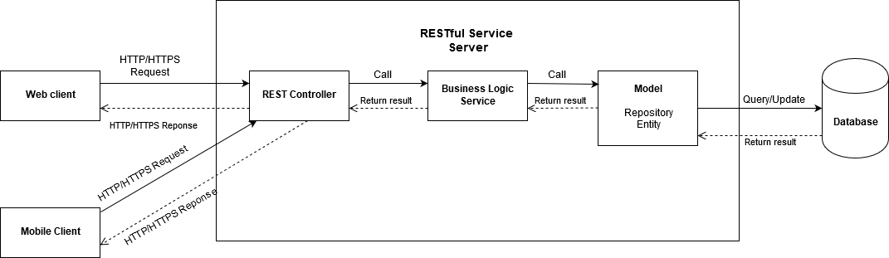

Figure 1 - System Architecture Design

Our system has been developed under the 3-layer architecture. The 3-layer architecture is different from the 3-tier architecture, because 3 components are separated logically (can be deployed on the same server), not physically (on different servers).

We choose this architecture for our system because of following advantages:

* **Speed of development:** a specific layer can be upgraded with minimal impact on the other layers.
* **Scalability**: By separating out the different layers we can scale each independently depending on the need at any given time.
* **Performance:** This allows you to load balance each layer independently, improving overall performance with minimal resources.

The 3-layer architecture consists of:

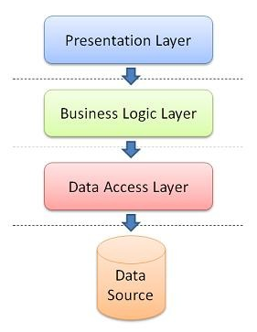

* **Presentation Layer:** consists of the user interface. This user interface is often a graphical one accessible through a web browser or web-based application and which displays content and information useful to an end user.
* **Business Logic Layer:** contains the functional business logic which drives an application’s core capabilities.
* **Data Access Layer:** provides simplified access to data source.

## **Component Diagram**

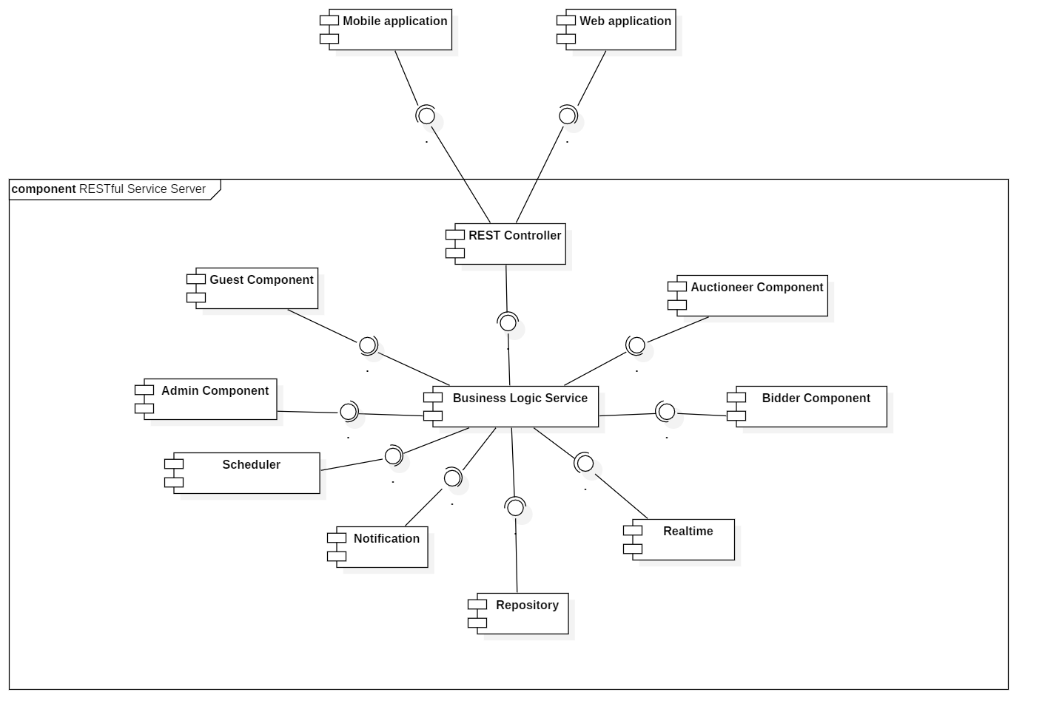

Figure 2 - Component Diagram

|  |  |
| --- | --- |
| COMPONENT DICTIONARY: DESCRIBES COMPONENTS | |
| Mobile Application | Component to contain system’s functions for end user on mobile device |
| Web Application | Component to contain system’s functions for end user on web |
| REST Controller | Component to receive requests, call services to process information, get data back from services and respond result to clients |
| Business Logic Service | Component to handle system’s business operations |
| Guest Component | Component to handle guest’s activities in the system |
| Admin Component | Component to handle admin’s activities in the system |
| Bidder Component | Component to handle bidder’s activities in the system |
| Auctioneer Component | Component to handle auctioneer’s activities in the system |
| Scheduler | Component to handle scheduling future tasks |
| Realtime | Component to handle realtime operations |
| Notification | Component to handle sending notifications |
| Repository Component | Component to handle data reading/writing operations from/to database |

Table 1 - Component Dictionary

## **Details Description**

### Class Diagram

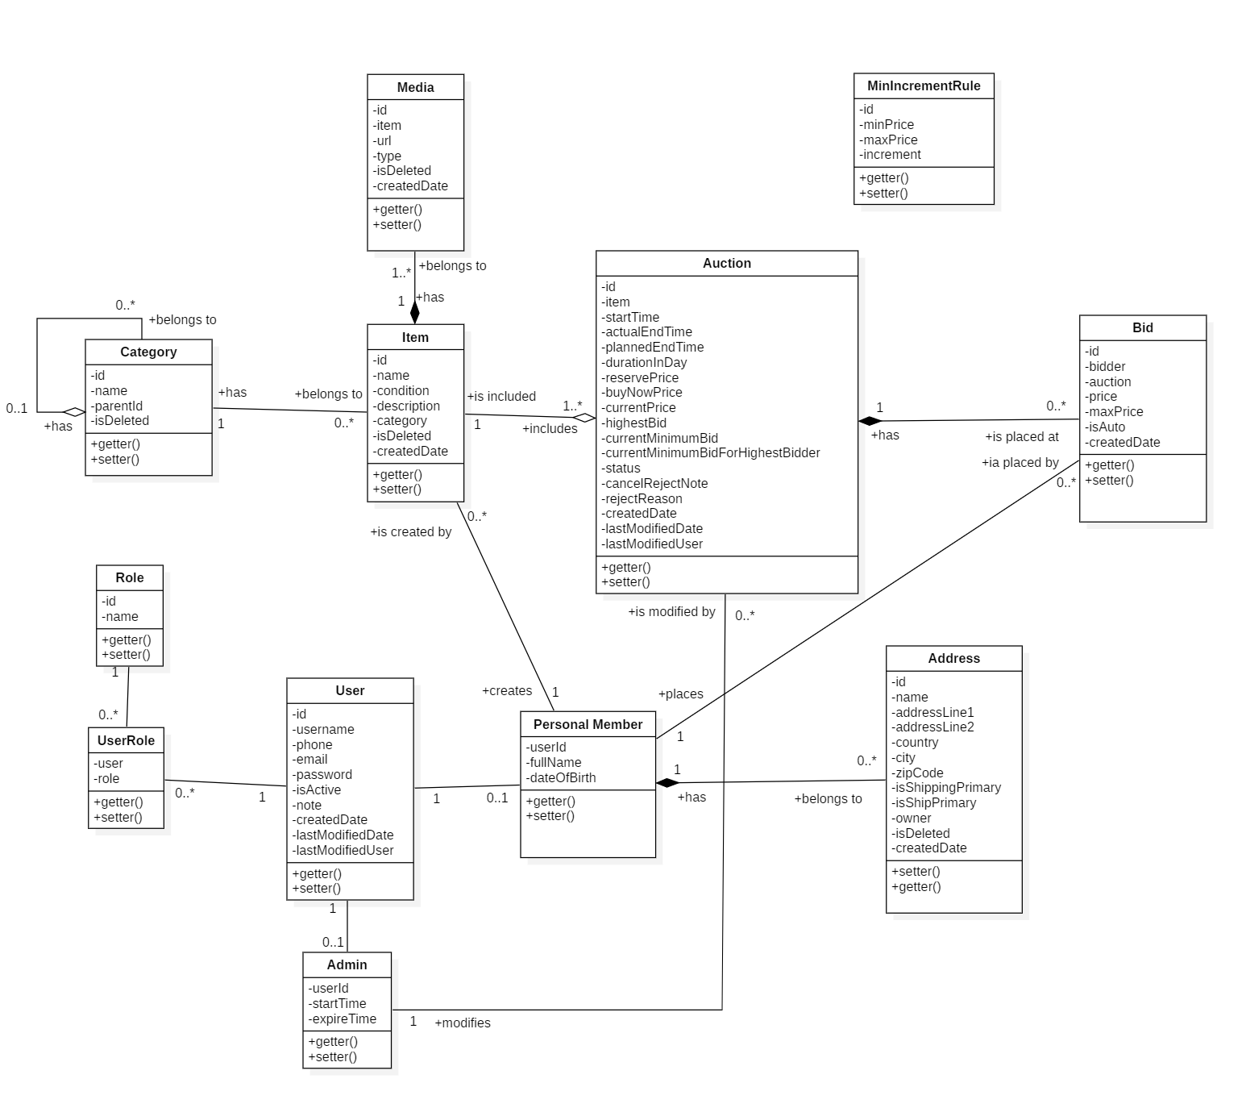

Figure 3 - Class Diagram

|  |  |  |
| --- | --- | --- |
| CLASS DICTIONARY: DESCRIBE CLASS | | |
| Class Name | **Mapping column with Conceptual diagram** | **Description** |
| User | User | Contains the user information |
| Admin | Admin | Contains the admin information |
| Personal Member | Auctioneer/Bidder | Contains the personal member (auctioneer, bidder) information |
| Role | Role | Contains the role information |
| UserRole | N/A | Contain the user’s roles information |
| Address | Address | Contain the address roles information |
| Item | Item | Contains the item information |
| Auction | Auction | Contains the auction information |
| Category | Category | Contains the category information |
| Media | Media | Contains the media information |
| Bid | Bid | Contains the bid information |
| MinIncrementRule | N/A | Contains the minimum increment rule information (for calculating minimum bid that bidder has to place on an item). |

Table 2 - Class Dictionary

### Class Diagram Explanation

#### User

|  |  |  |  |
| --- | --- | --- | --- |
| **Attribute** | **Type** | **Visibility** | **Description** |
| id | Integer | Private | Unique identifier of a user |
| username | String | Private | User’s username |
| password | String | Private | User’s password |
| phone | String | Private | User’s phone |
| email | String | Private | User’s email |
| status | String | Private | User’s status |
| note | String | Ptivate | User’s note (reason for being restricted) |
| createdDate | ZonedDateTime | Private | User’s created date |
| lastModifiedDate | ZonedDateTime | Private | User’s last modified date |
| lastModifiedUser | User | Private | User who modified lastly this one |
| **Method** | **Return Type** | **Visibility** | **Description** |
| getter | Attribute type | Public | Get value of attribute |
| setter | Void | Public | Set value for attribute |

Table 3 - Class Diagram Explanation <User>

#### Admin

|  |  |  |  |
| --- | --- | --- | --- |
| **Attribute** | **Type** | **Visibility** | **Description** |
| userId | Integer | Private | Unique identifier of an admin (from that of his/her user account) |
| startTime | ZonedDateTime | Private | Admin’s start time for performing operations |
| expireTime | ZonedDateTime | Private | Admin’s expire time for performing operations |
| **Method** | **Return Type** | **Visibility** | **Description** |
| getter | Attribute type | Public | Get value of attribute |
| setter | Void | Public | Set value for attribute |

Table 4 - Class Diagram Explanation <Admin>

#### Personal member

|  |  |  |  |
| --- | --- | --- | --- |
| **Attribute** | **Type** | **Visibility** | **Description** |
| userId | Integer | Private | Unique identifier of a personal member (from that of his/her user account) |
| fullName | String | Private | Personal member’s full name |
| dateOfBirth | ZonedDateTime | Private | Personal member’s date of birth |
| **Method** | **Return Type** | **Visibility** | **Description** |
| getter | Attribute type | Public | Get value of attribute |
| setter | Void | Public | Set value for attribute |

Table 5 - Class Diagram Explanation <Personal member>

#### Role

|  |  |  |  |
| --- | --- | --- | --- |
| **Attribute** | **Type** | **Visibility** | **Description** |
| id | Integer | Private | Unique identifier of a role |
| name | String | Private | Role’s name |
| **Method** | **Return Type** | **Visibility** | **Description** |
| getter | Attribute type | Public | Get value of attribute |
| setter | Void | Public | Set value for attribute |

Table 6 - Class Diagram Explanation <Role>

#### UserRole

|  |  |  |  |
| --- | --- | --- | --- |
| **Attribute** | **Type** | **Visibility** | **Description** |
| user | User | Private | User who is assigned to the role |
| role | Role | Private | Role which is assigned to the user |
| **Method** | **Return Type** | **Visibility** | **Description** |
| getter | Attribute type | Public | Get value of attribute |
| setter | Void | Public | Set value for attribute |

Table 7 - Class Diagram Explanation <UserRole>

#### Address

|  |  |  |  |
| --- | --- | --- | --- |
| **Attribute** | **Type** | **Visibility** | **Description** |
| id | Integer | Private | Unique identifier of an address |
| name | String | Private | Address’s name |
| addressLine1 | String | Private | Address’s addressline1 (Street name, town, ward, etc) |
| addressLine2 | String | Private | Address’s addressline2 (floor number, apartment number, etc) |
| country | String | Private | Address’s country |
| zipCode | String | Private | Address’s ZIP code or portal code |
| isShippingPrimary | String | Private | Is address is default for shipping address or not (receiving item) |
| isShipPrimary | String | Private | Is address is default for ship address or not (sending item) |
| owner | User | Private | Address’s owner |
| isDeleted | Boolean | Private | Address is deleted or not |
| createdDate | ZonedDateTime | Private | Address’s created date |
| **Method** | **Return Type** | **Visibility** | **Description** |
| getter | Attribute type | Public | Get value of attribute |
| setter | Void | Public | Set value for attribute |

Table 8 - Class Diagram Explanation <Address>

#### Item

|  |  |  |  |
| --- | --- | --- | --- |
| **Attribute** | **Type** | **Visibility** | **Description** |
| id | Integer | Private | Unique identifier of an item |
| name | String | Private | Item’s name |
| condition | String | Private | Item’s condition |
| category | Category | Private | Item’s category |
| isDeleted | Boolean | Private | Item is deleted or not |
| createdDate | ZonedDateTime | Private | Item’s created date |
| **Method** | **Return Type** | **Visibility** | **Description** |
| getter | Attribute type | Public | Get value of attribute |
| setter | Void | Public | Set value for attribute |

Table 9 - Class Diagram Explanation <Item>

#### Auction

|  |  |  |  |
| --- | --- | --- | --- |
| **Attribute** | **Type** | **Visibility** | **Description** |
| id | Integer | Private | Unique identifier of an item |
| item | Item | Private | Auction’s item |
| startTime | ZonedDateTime | Private | Auction’s start time |
| actualEndTime | ZonedDateTime | Private | Auction’s actual end time |
| durationInDays | ZonedDateTime | Private | Auction’s duration in days |
| plannedEndTime | ZonedDateTime | Private | Auction’s planned end time |
| reservePrice | BigDecimal | Private | Auction’s reserve price |
| buyNowPrice | BigDecimal | Private | Auction’s buy now price |
| currentPrice | BigDecimal | Private | Auction’s current price |
| highestBid | Bid | Private | Auction’s highest bid |
| currentMinimumBid | BigDecimal | Private | Auction’s current minimum bid |
| currentMinimumBid  ForHighestBidder | BigDecimal | Private | Auction’s current minimum bid for highest bidder |
| status | String | Private | Auction’s status |
| note | String | Private | Auction’s note for being rejected by admin |
| rejectReason | String | Private | Auction’s reason for being rejected by admin |
| createdDate | ZonedDateTime | Private | Auction’s created date |
| lastModifiedDate | ZonedDateTime | Private | Auction’s last modified date |
| lastModifiedUser | User | Private | User who modified lastly this auction |
| **Method** | **Return Type** | **Visibility** | **Description** |
| getter | Attribute type | Public | Get value of attribute |
| setter | Void | Public | Set value for attribute |

Table 10 - Class Diagram Explanation <Auction>

#### Category

|  |  |  |  |
| --- | --- | --- | --- |
| **Attribute** | **Type** | **Visibility** | **Description** |
| id | Integer | Private | Unique identifier of category |
| name | String | Private | Category’s name |
| parentId | Integer | Private | Unique identifier of category’s parent |
| isDeleted | Boolean | Private | Category is deleted or not |
| **Method** | **Return Type** | **Visibility** | **Description** |
| getter | Attribute type | Public | Get value of attribute |
| setter | Void | Public | Set value for attribute |

Table 11 - Class Diagram Explanation <Category>

#### Media

|  |  |  |  |
| --- | --- | --- | --- |
| **Attribute** | **Type** | **Visibility** | **Description** |
| id | Integer | Private | Unique identifier of media |
| item | Item | Private | Media’s Item |
| url | String | Private | Media’s URL |
| type | String | Private | Media’s type |
| isDeleted | Boolean | Private | Media is deleted or not |
| createdDate | ZonedDateTime | Private | Media’s created date |
| **Method** | **Return Type** | **Visibility** | **Description** |
| getter | Attribute type | Public | Get value of attribute |
| setter | Void | Public | Set value for attribute |

Table 11 - Class Diagram Explanation <Media>

#### Bid

|  |  |  |  |
| --- | --- | --- | --- |
| **Attribute** | **Type** | **Visibility** | **Description** |
| id | Integer | Private | Unique identifier of bid |
| bidder | User | Private | Bid’s bidder |
| auction | Auction | Private | Bid’s auction |
| price | BigDecimal | Private | Bid’s price |
| maxPrice | BigDecimal | Private | Bid’s maxPrice |
| isAuto | Boolean | Private | Bid is placed by automatic bidding system or not |
| createdDate | ZonedDateTime | Private | Bid’s created date |
| **Method** | **Return Type** | **Visibility** | **Description** |
| getter | Attribute type | Public | Get value of attribute |
| setter | Void | Public | Set value for attribute |

Table 12 - Class Diagram Explanation <Bid>

#### MinIncrementRule

|  |  |  |  |
| --- | --- | --- | --- |
| **Attribute** | **Type** | **Visibility** | **Description** |
| id | Integer | Private | Unique identifier of rule |
| minPrice | BigDecimal | Private | Rule’s minimum price |
| maxPrice | BigDecimal | Private | Rule’s maximum price |
| increment | BigDecimal | Private | Rule’s increment |
| **Method** | **Return Type** | **Visibility** | **Description** |
| getter | Attribute type | Public | Get value of attribute |
| setter | Void | Public | Set value for attribute |

Table 13 - Class Diagram Explanation <MinIncrementRule>

### Interactive Diagram

#### Guest

##### Login

Summary: this diagram shows process for login.

x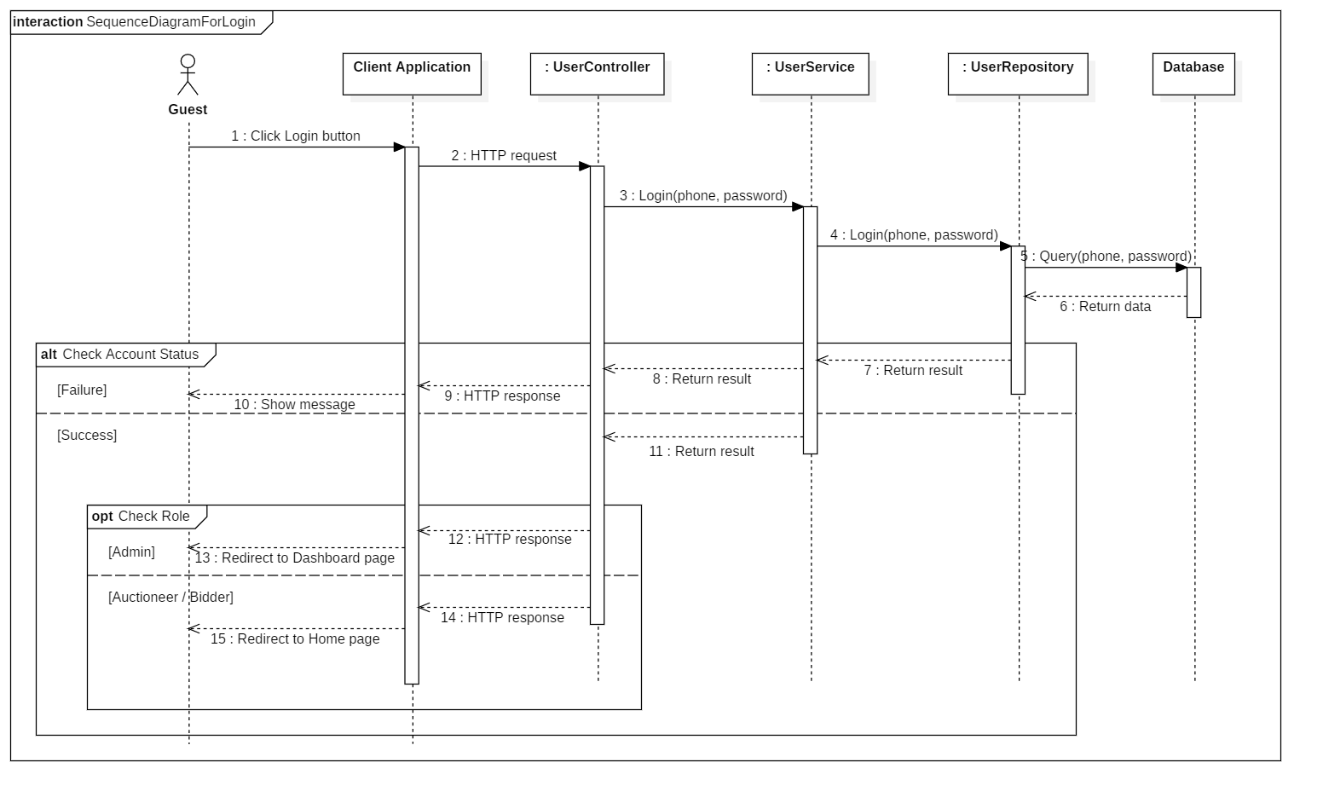

Figure 4 - Sequence Diagram for Login < Guest >

##### Register account

Summary: this diagram shows process for register account.

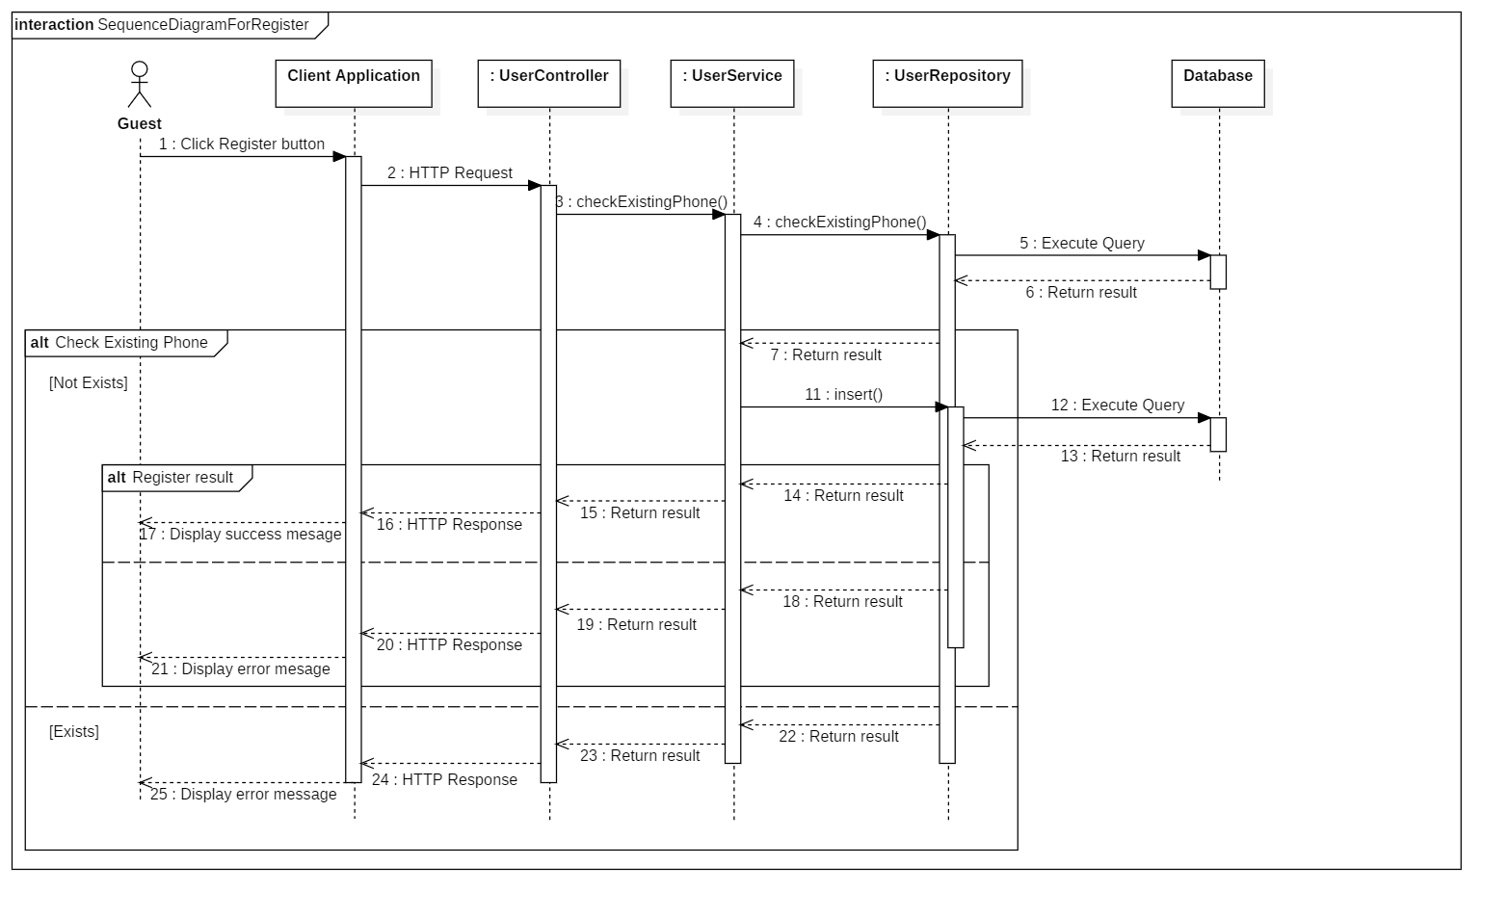

Figure 5 - Sequence Diagram for Register Account < Guest >

##### Search Auctions

Summary: this diagram shows process for search auctions (by keyword/ category).

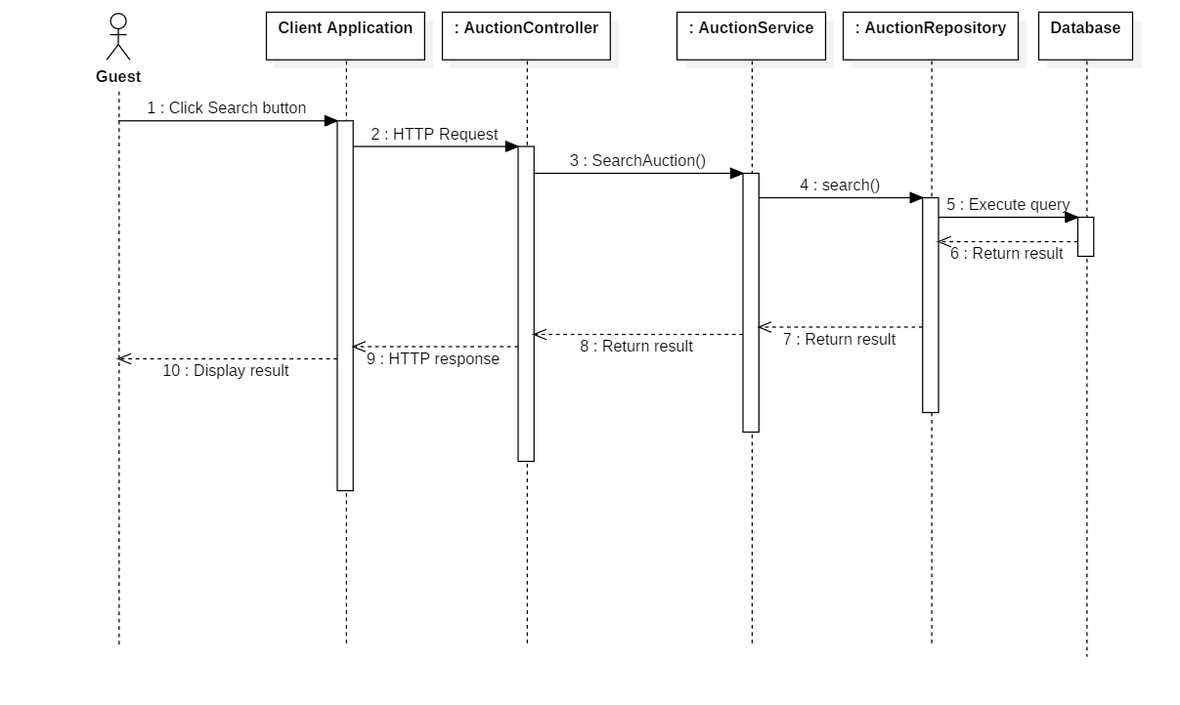

Figure 6 - Sequence Diagram for Search Auctions < Guest >

##### View Auction Details

Summary: this diagram shows process for view auction details.

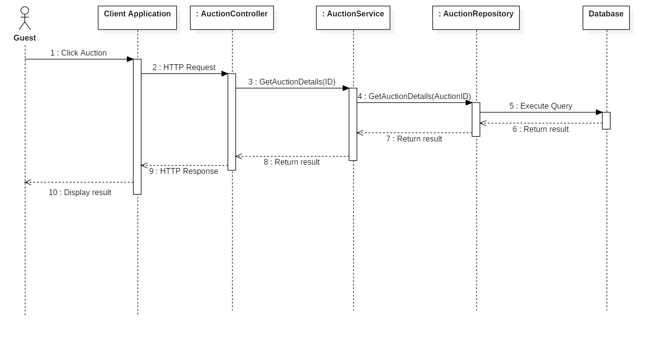

Figure 7 - Sequence Diagram for View Auction Details < Guest >

##### View Suggested Auctions

Summary: this diagram shows process for view suggested auctions

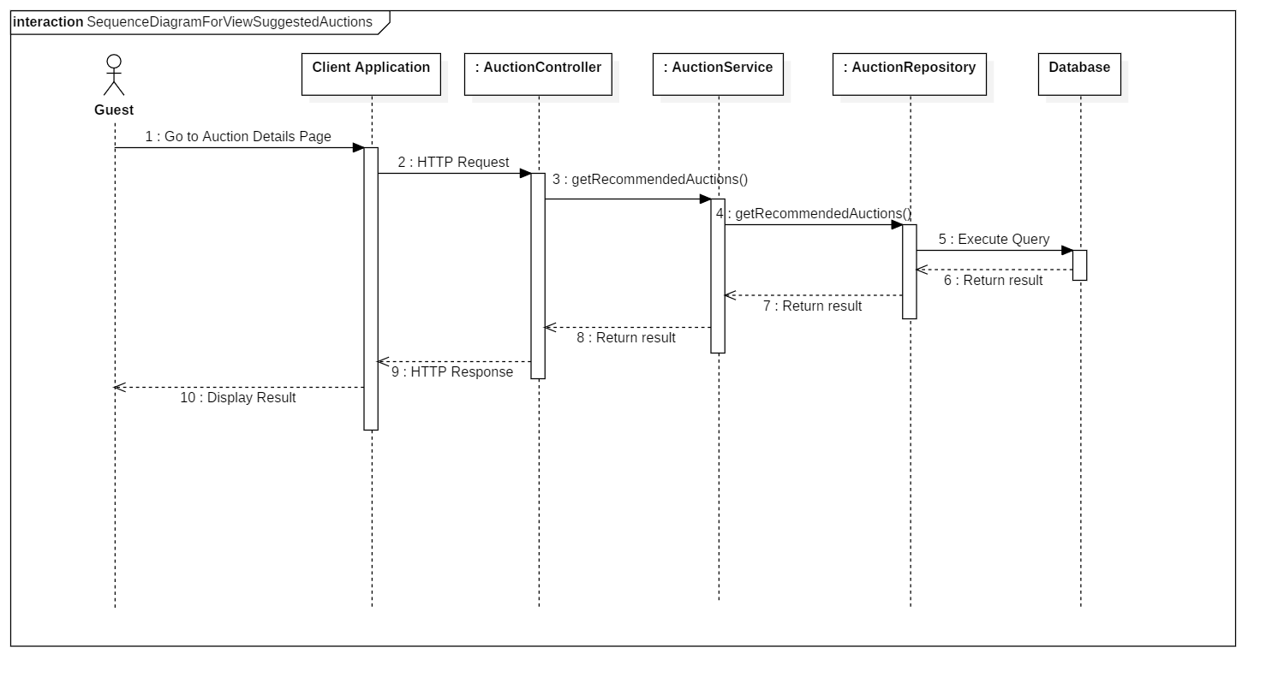

Figure 8 - Sequence Diagram for View Suggested Auctions < Guest >

#### Administrator

##### Accept Auction

Summary: this diagram shows process for accept auction.

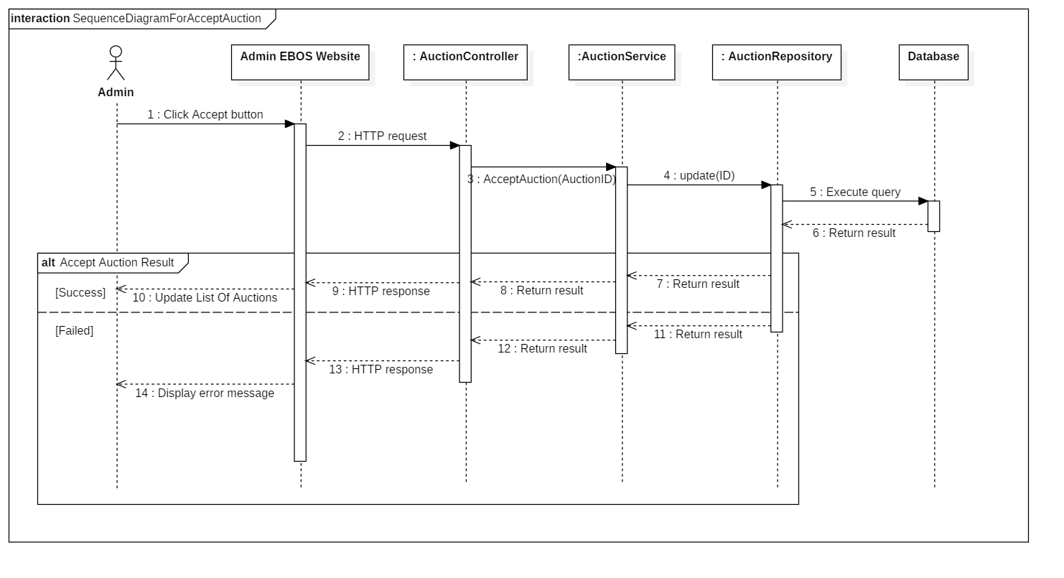

Figure 9 - Sequence Diagram for Accept Auction < Administrator >

##### Reject Auction

Summary: this diagram shows process for reject auction.

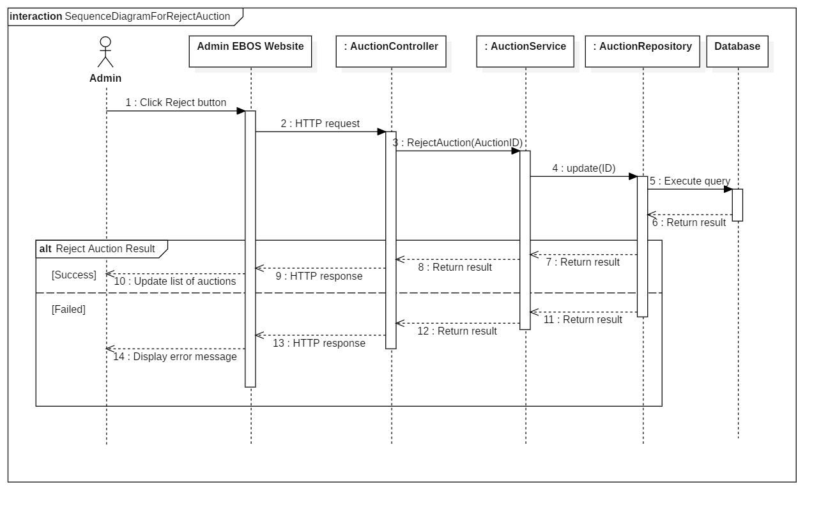

Figure 10 - Sequence Diagram for Reject Auction < Administrator >

##### Search Users

Summary: this diagram shows process for search users.

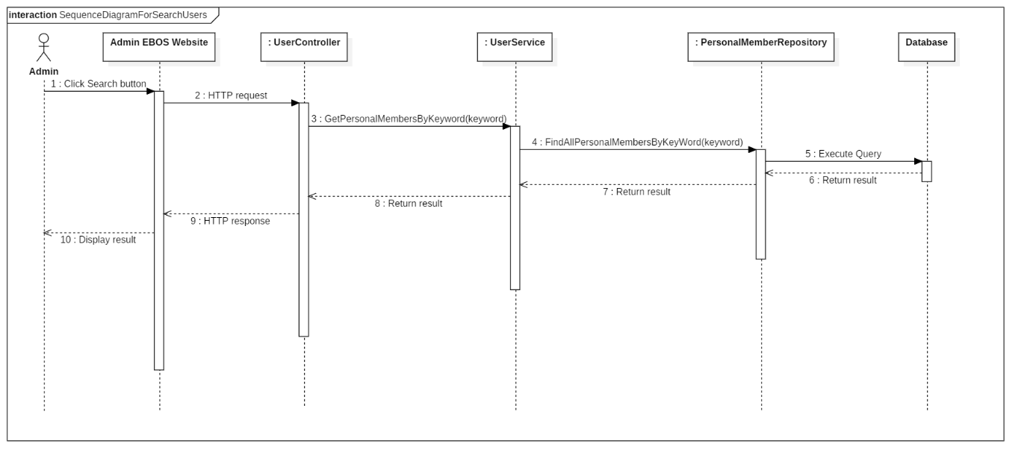

Figure 11 - Sequence Diagram for Search Users < Administrator >

##### Activate User

Summary: this diagram shows process for activate user.

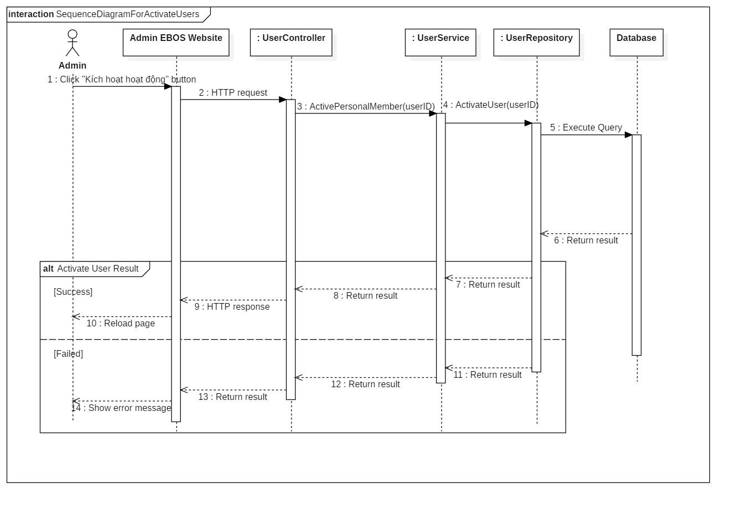

Figure 12 - Sequence Diagram for Activate User < Administrator >

##### Restrict User

Summary: this diagram shows process for restrict user.

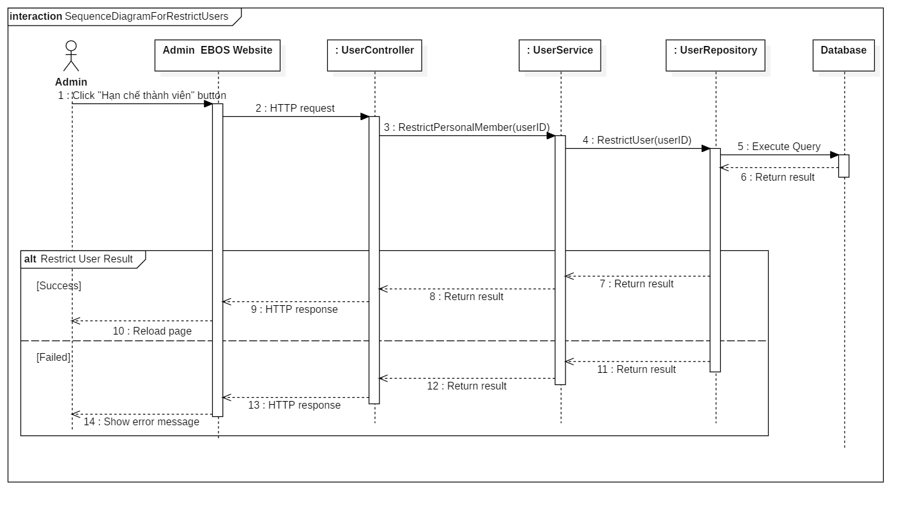

Figure 13 - Sequence Diagram for Restrict User < Administrator >

#### Auctioneer

##### Submit Auction

Summary: this diagram shows process for submit auction.

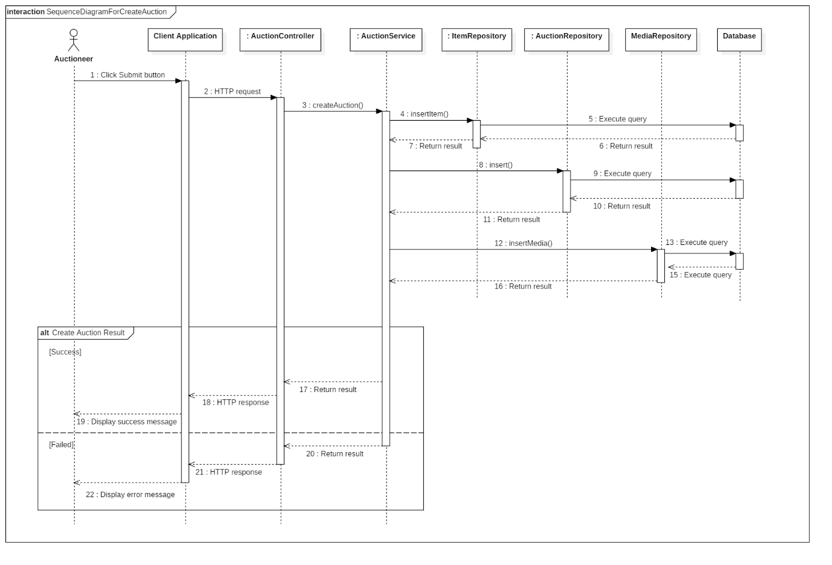

Figure 14 - Sequence Diagram for Submit Auction < Auctioneer >

#### Bidder

##### Place Bid

Summary: this diagram shows process for place bid.

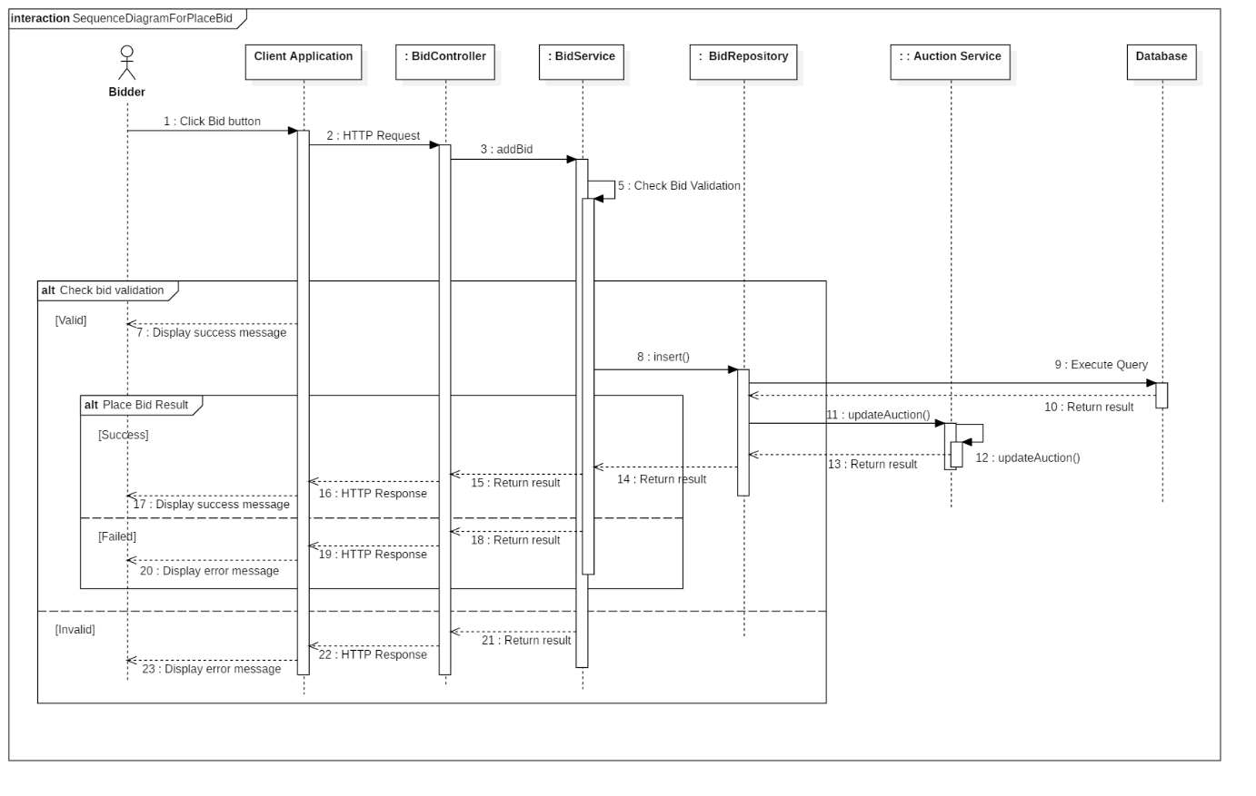

Figure 15 - Sequence Diagram for Place Bid < Bidder >

#### Auctioneer & Bidder

##### View Auction History

Summary: this diagram shows process for view auction history.

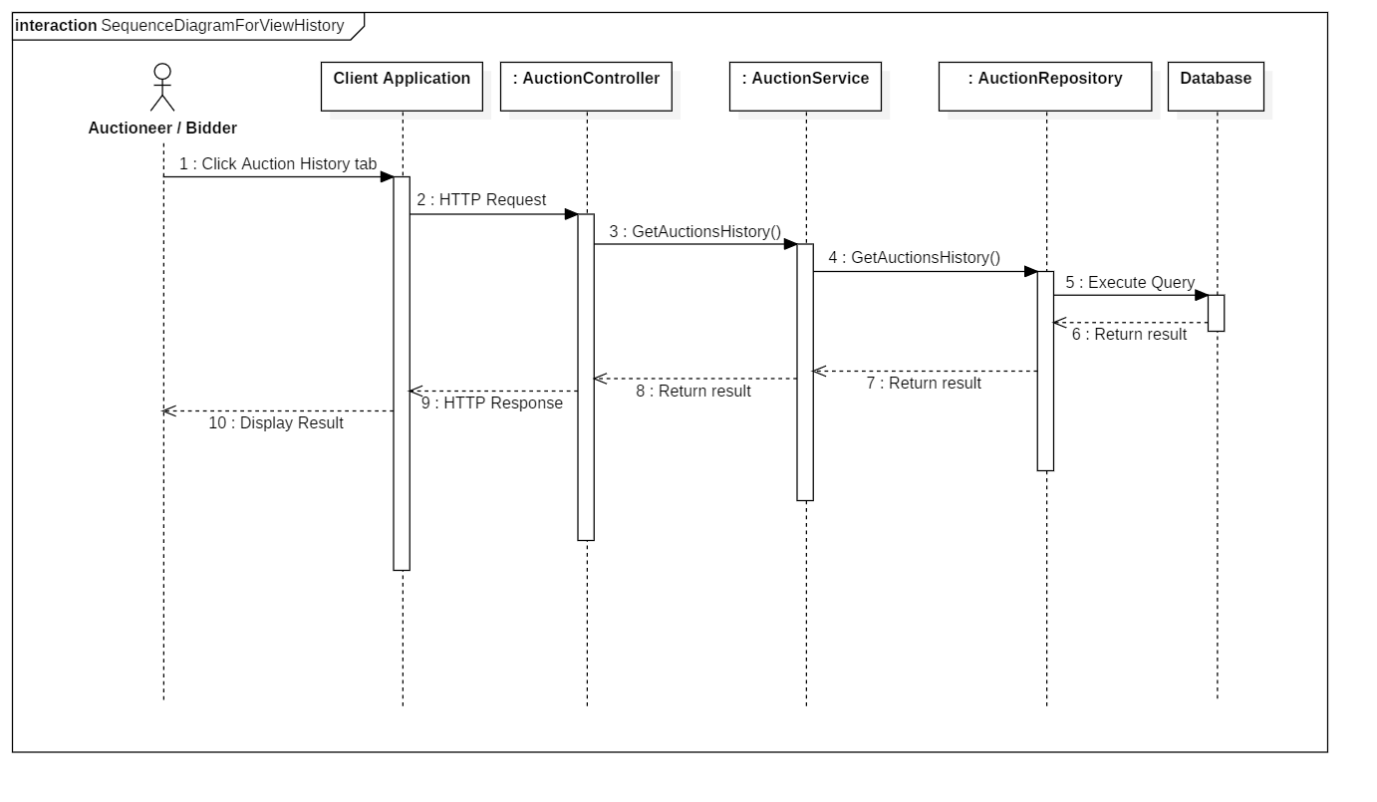

Figure 16 - Sequence Diagram for View Auction History < Auctioneer/Bidder >

##### Register address

Summary: this diagram shows process for register address.

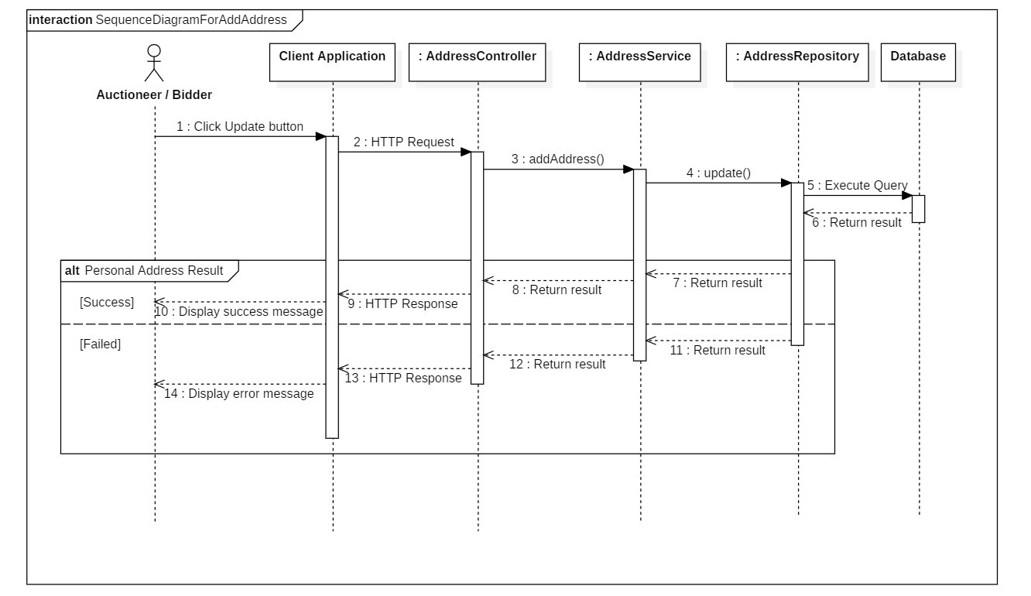

Figure 17 - Sequence Diagram for Register Address < Auctioneer/Bidder >

##### View Contact Information

Summary: this diagram shows process for view contact information of:

* winner of auction for seller
* seller of won auction for bidder

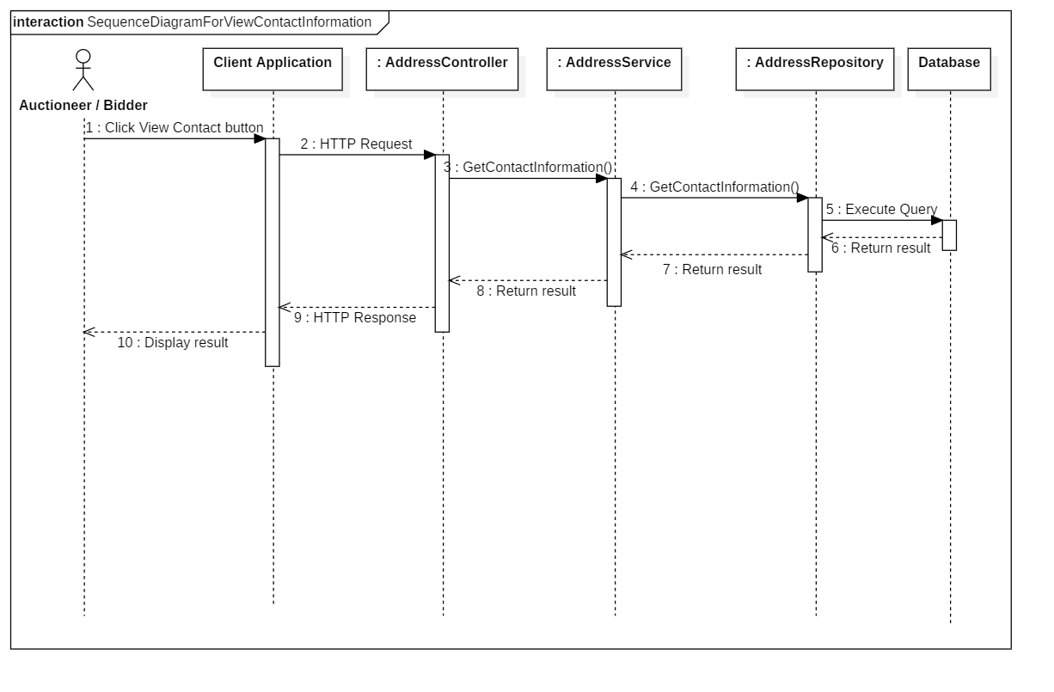

Figure 18 - Sequence Diagram for View Contact Information` < Auctioneer/Bidder >

### State Machine Diagram

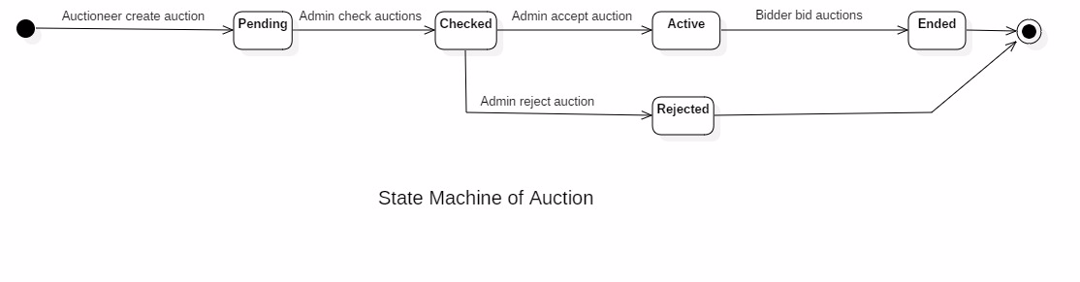

Figure 19 - State Machine Diagram of Auction

## **User Interface Design**

### Web admin application user interface

#### Login

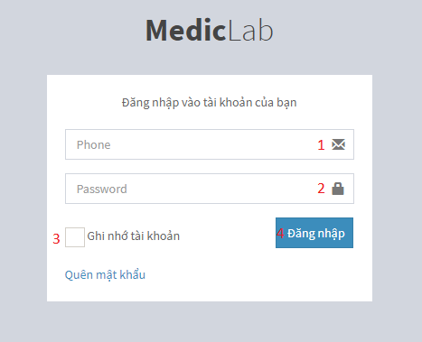

Figure 20 - Web Interface <Login>

**Field**

|  |  |  |  |  |  |  |  |
| --- | --- | --- | --- | --- | --- | --- | --- |
| **No** | **Field Name** | **Description** | **Read only** | **Mandatory** | **Control Type** | **Data Type** | **Length** |
| 1 | Phone | Phone to login | No | Yes | Textbox | String |  |
| 2 | Password | Password to login | No | Yes | Textbox | String | 8-255 |
| 3 | Remember me | Auto log in | No | No | Checkbox | Boolean |  |

**Buttons/Hyperlinks:**

|  |  |  |  |  |
| --- | --- | --- | --- | --- |
| **No** | **Function** | **Description** | **Validation** | **Outcome** |
| 4 | Sign In | Login into system | Validate all required fields | Navigate to Admin page |

#### View Hospital Receptionist Page

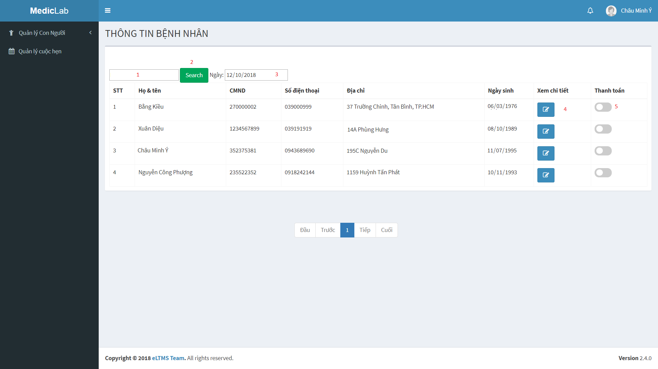

Figure 21 - Admin Web Interface <View Hospital Receptionist>

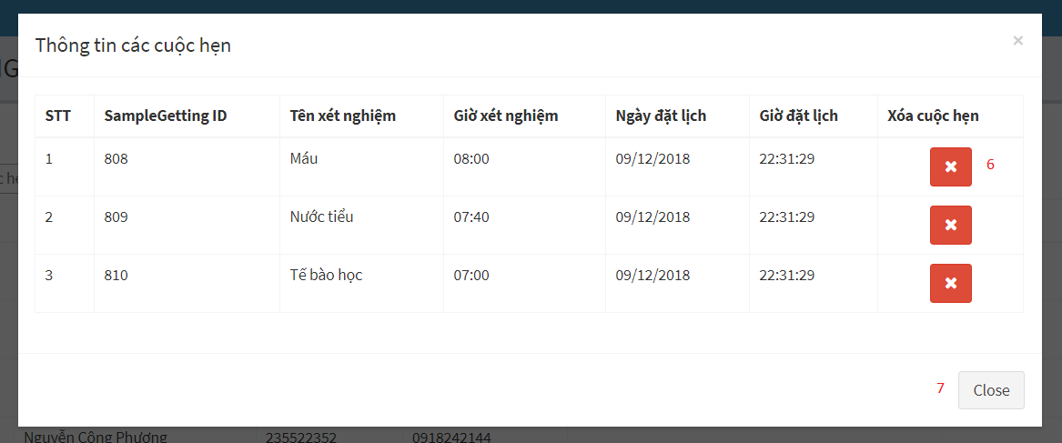

Figure 22 - Admin Web Interface <View Hospital Receptionist>

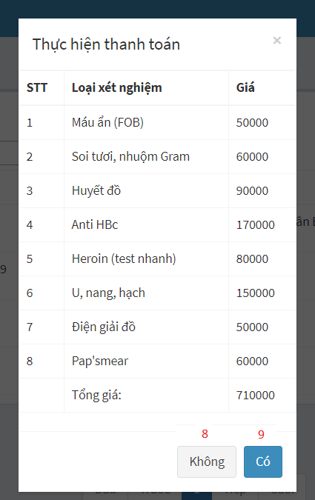

Figure 23 - Admin Web Interface <View Hospital Receptionist>

**Field**

|  |  |  |  |  |  |  |  |
| --- | --- | --- | --- | --- | --- | --- | --- |
| **No** | **Field Name** | **Description** | **Read only** | **Mandatory** | **Control Type** | **Data Type** | **Length** |
| 1 | Keyword | Fill keyword to search | No | Yes | Text | String |  |
| 3 | Select Date | Select Date to show Patient | No | Yes | Date | Date |  |

**Buttons/Hyperlinks**

|  |  |  |  |  |
| --- | --- | --- | --- | --- |
| **No** | **Function** | **Description** | **Validation** | **Outcome** |
| 2 | Search | Search after getting keywork | N/A | Show list of patients by keywork |
| 4 | Show details appointment | Show list of appointments | N/A | Show list of appointments |
| 5 | Change status | Show popup for admin to check hospital fee for patient and pay it | N/A | Show list of price and confirm Y/N to change status |
| 6 | Delete sampleGetting | Delete sampleGetting after getting request | N/A | SampleGetting is deleted |
| 7 | Close popup | Close popup details appointment | N/A | Popup is closed |
| 8 | Cancel paying | Confirm payment | N/A | Status is not changed |
| 9 | Accept paying | Confirm payment | N/A | Status is changed |

#### View Department Receptionist Page

# 

Figure 24 - Admin Web Interface <View Department Receptionist>

# 

Figure 25 - Admin Web Interface <View Department Receptionist>

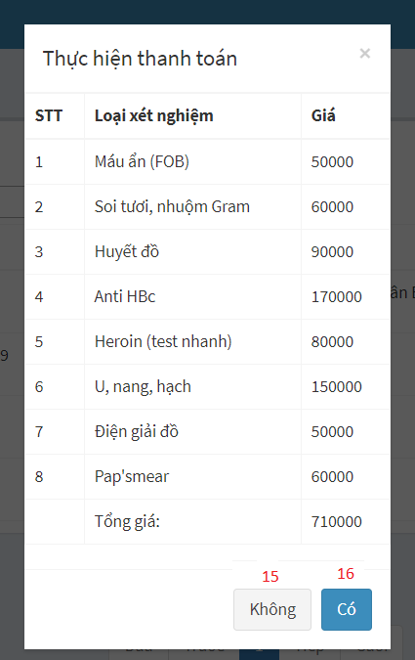

Figure 26 - Admin Web Interface <View Department Receptionist>

**Field**

|  |  |  |  |  |  |  |  |
| --- | --- | --- | --- | --- | --- | --- | --- |
| **No** | **Field Name** | **Description** | **Read only** | **Mandatory** | **Control Type** | **Data Type** | **Length** |
| 2 | Keyword | Fill keyword to search | No | Yes | Text | String |  |
| 4 | Select sample | Select sample to show appointment | No | Yes | Dropdown list | String |  |
| 5 | Select Date | Select date to show appointment | No | Yes | Date | Date |  |
| 7 | Họ và Tên | Patient’s information | No | Yes | Textbox | String |  |
| 8 | CMND | Patient’s information | No | Yes | Textbox | String |  |
| 9 | Ngày sinh | Patient’s information | No | Yes | Date | Date |  |
| 10 | Số điện thoại | Patient’s information | No | Yes | Textbox | String |  |
| 11 | Địa chỉ | Patient’s information | No | Yes | Textbox | String |  |
| 12 | Loại xét nghiệm | Choose labtest | No | Yes | Checkbox | Boolean |  |

**Buttons/Hyperlinks:**

|  |  |  |  |  |
| --- | --- | --- | --- | --- |
| **No** | **Function** | **Description** | **Validation** | **Outcome** |
| 1 | Create appointment | Create appointment for patient | N/A | Show popup appointment’s information |
| 3 | Search | Search after getting keywork | N/A | Show list of appointments by keywork |
| 6 | Change status | Show popup for admin to check hospital fee for patient and pay it | N/A | Show list of price and confirm Y/N to change status |
| 13 | Add a new appointment | Add a new appointment | N/A | A new appointment is created |
| 14 | Close popup | Close popup details appointment | N/A | Popup is closed |
| 15 | Cancel paying | Confirm payment | N/A | Status is not changed |
| 16 | Accept paying | Confirm payment | N/A | Status is changed |

#### View Nurse Page

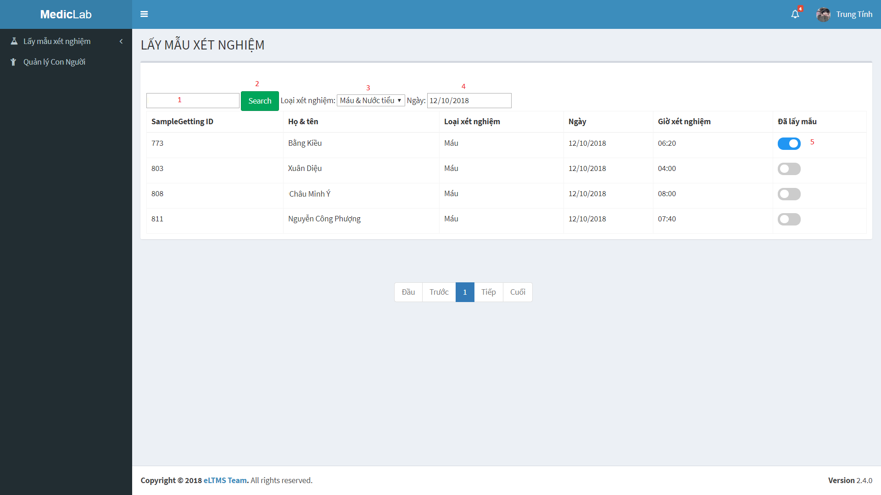

Figure 27 - Admin Web Interface <View Nurse>

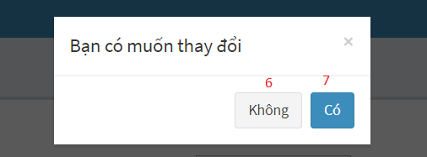

Figure 28 - Admin Web Interface <View Nurse>

**Field**

|  |  |  |  |  |  |  |  |
| --- | --- | --- | --- | --- | --- | --- | --- |
| **No** | **Field Name** | **Description** | **Read only** | **Mandatory** | **Control Type** | **Data Type** | **Length** |
| 1 | Keyword | Fill Keyword to seach | No | Yes | Text | String |  |
| 3 | Select sample | Select sample to show appointment | No | Yes | Dropdown list | String |  |
| 4 | Select Date | Select date to show appointment | No | Yes | Date | Date |  |

**Buttons/Hyperlinks**

|  |  |  |  |  |
| --- | --- | --- | --- | --- |
| **No** | **Function** | **Description** | **Validation** | **Outcome** |
| 2 | Search | Search after getting keywork | N/A | Show list of appointment by keywork |
| 5 | Change status | Show popup for admin to confirm and change status | N/A | Show options to choose Y/N |
| 6 | Cancel action | Choose No | N/A | Status is not changed |
| 7 | Accept action | Choose Yes | N/A | Status is changed |

#### View Laboratory Technician Page

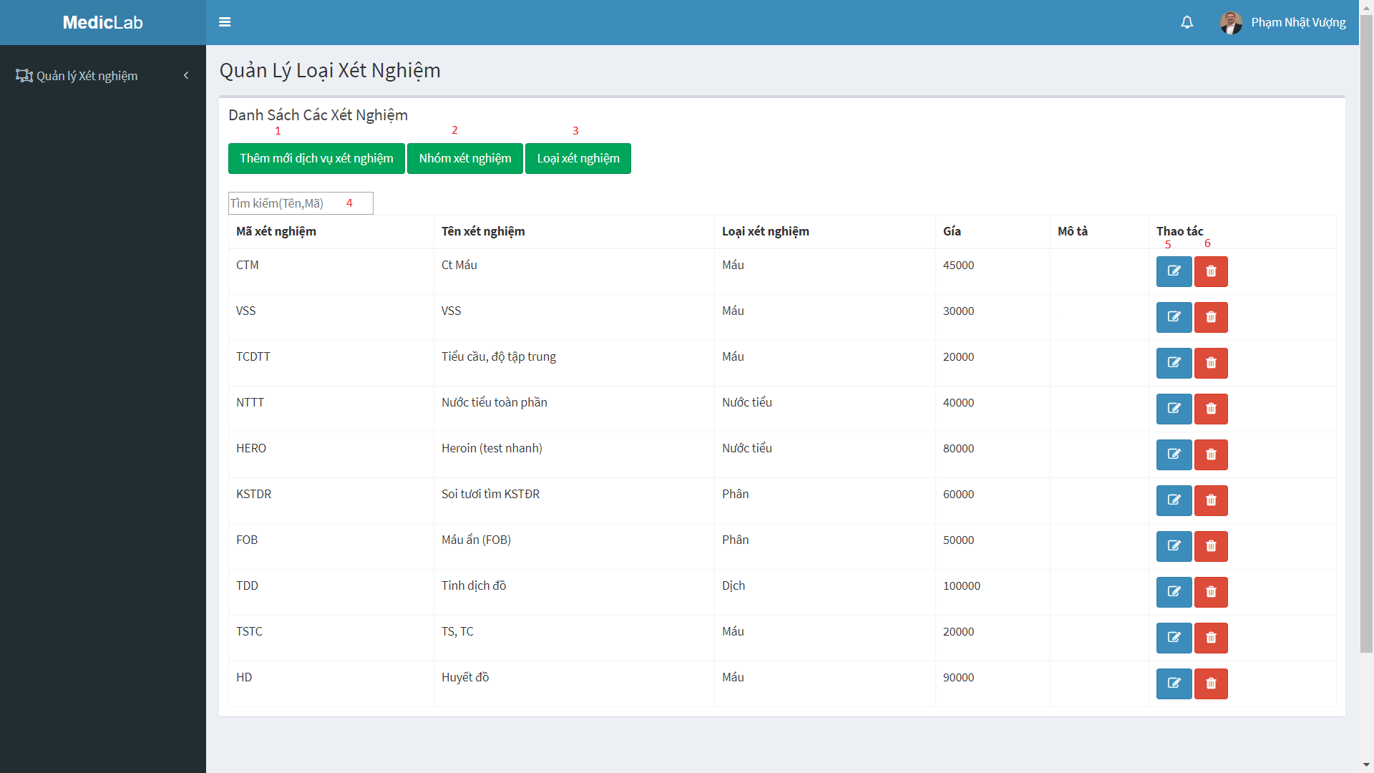

Figure 29 - Admin Web Interface <View Laboratory Technician>

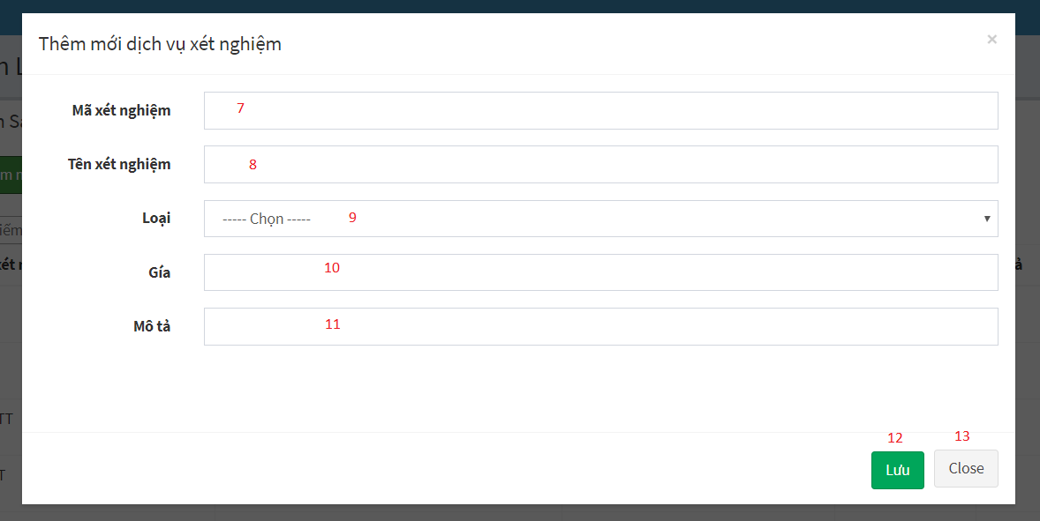

Figure 30 - Admin Web Interface <View Laboratory Technician-Add Labtest>

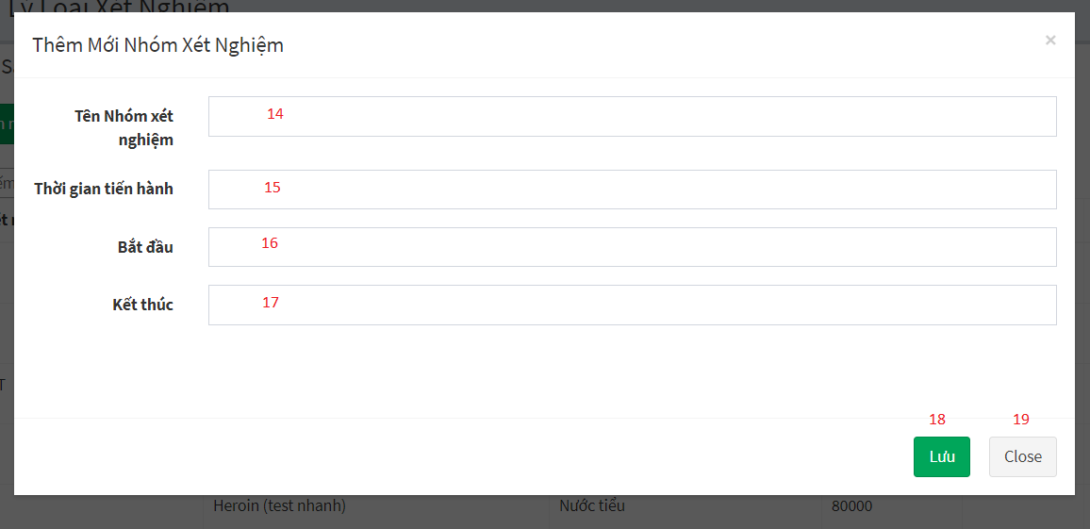

Figure 31 - Admin Web Interface <View Laboratory Technician-Add Sample group>

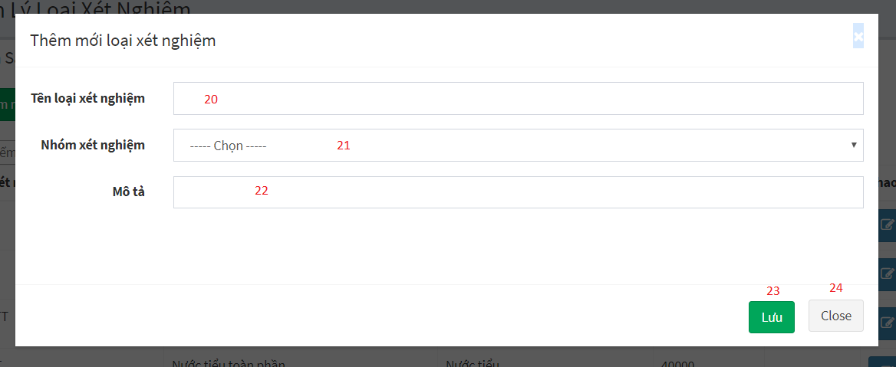

Figure 32 - Admin Web Interface <View Laboratory Technician-Add Sample>

**Field**

|  |  |  |  |  |  |  |  |
| --- | --- | --- | --- | --- | --- | --- | --- |
| **No** | **Field Name** | **Description** | **Read only** | **Mandatory** | **Control Type** | **Data Type** | **Length** |
| 4 | Keyword | Fill keyword to seach | No | Yes | Text | String |  |
| 7 | Mã xét nghiệm | Labtest’s information | No | Yes | Textbox | String |  |
| 8 | Tên xét nghiệm | Labtest’s information | No | Yes | Textbox | String |  |
| 9 | Loại | Labtest’s information | No | Yes | Dropdown list | String |  |
| 10 | Giá | Labtest’s information | No | Yes | Textbox | String |  |
| 11 | Mô tả | Labtest’s information | No | Yes | Textbox | String |  |
| 14 | Tên nhóm xét nghiệm | Sample group’s information | No | Yes | Textbox | String |  |
| 15 | Thời gian tiến hành | Sample group’s information | No | Yes | Textbox | String |  |
| 16 | Bắt đầu | Sample group’s information | No | Yes | Textbox | String |  |
| 17 | Kết thúc | Sample group’s information | No | Yes | Textbox | String |  |
| 20 | Tên loại xét nghiệm | Sample’s information | No | Yes | Textbox | String |  |
| 21 | Nhóm xét nghiệm | Sample’s information | No | Yes | Dropdown list | String |  |
| 22 | Mô tả | Sample’s information | No | Yes | Textbox | String |  |

**Buttons/Hyperlinks**

|  |  |  |  |  |
| --- | --- | --- | --- | --- |
| **No** | **Function** | **Description** | **Validation** | **Outcome** |
| 1 | Add new labtest | Add new labtest | N/A | Show popup to fill information of labtest |
| 2 | Add new sample group | Add new sample group | N/A | Show popup to fill information of sample group |
| 3 | Add new sample | Add new sample | N/A | Show popup to fill information of sample |
| 5 | Edit labtest | Edit information of labtest | N/A | Edit information of labtest |
| 6 | Delete labtest | Delete labtest after getting request | N/A | Labtest is deleted |
| 12 | Add a new labtest | Add a new labtest | N/A | A new labtest is created |
| 13 | Close popup | Close popup | N/A | Popup is closed |
| 18 | Add a new sample group | Add a new sample group | N/A | A new sample group is created |
| 19 | Close popup | Close popup | N/A | Popup is closed |
| 23 | Add a new sample | Add a new sample | N/A | A new sample is created |
| 24 | Close popup | Close popup | N/A | Popup is closed |

#### View Doctor Page

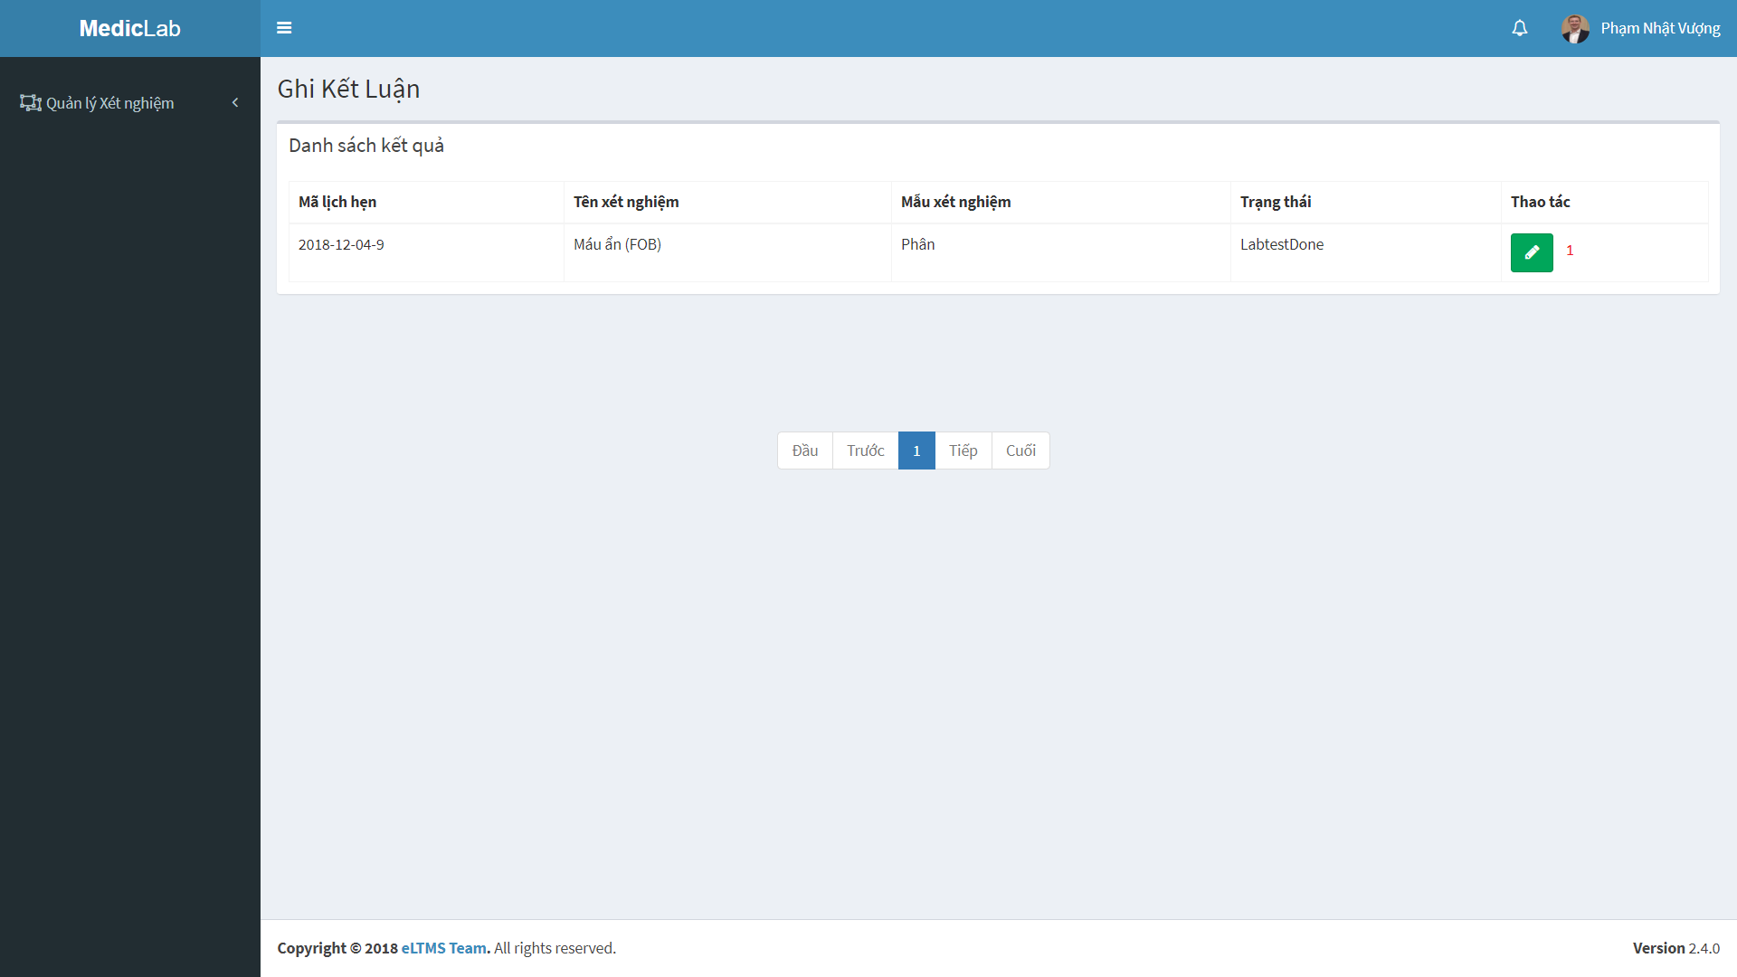

Figure 33 - Admin Web Interface <View Doctor>

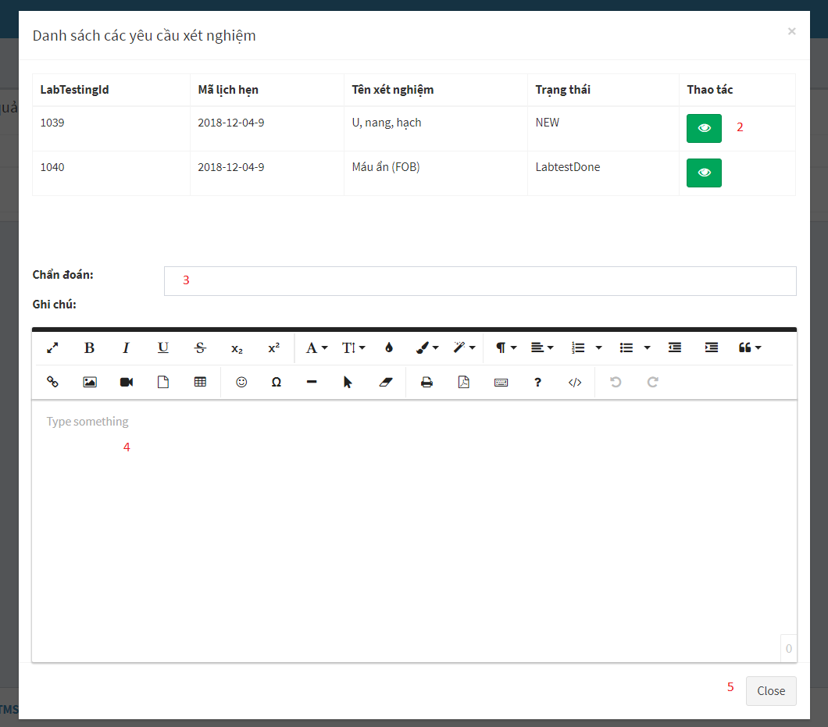

Figure 34 - Admin Web Interface <View Doctor>

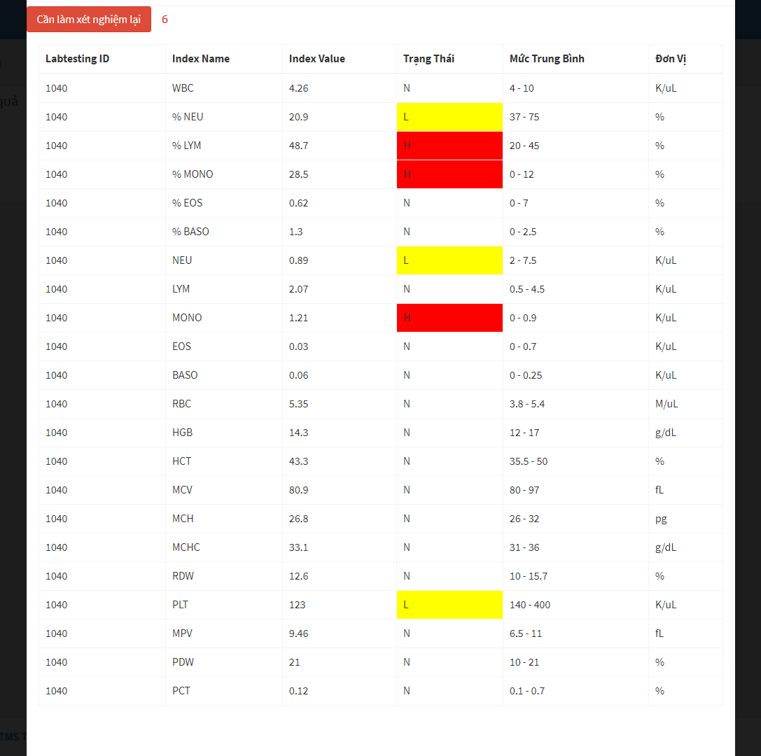

Figure 35 - Admin Web Interface <View Doctor>

**Field**

|  |  |  |  |  |  |  |  |
| --- | --- | --- | --- | --- | --- | --- | --- |
| **No** | **Field Name** | **Description** | **Read only** | **Mandatory** | **Control Type** | **Data Type** | **Length** |
| 3 | Chẩn đoán | Conclusion of doctor | No | Yes | Textbox | String |  |
| 4 | Ghi chú | Note of doctor | No | Yes | Textbox | String |  |

**Buttons/Hyperlinks**

|  |  |  |  |  |
| --- | --- | --- | --- | --- |
| **No** | **Function** | **Description** | **Validation** | **Outcome** |
| 1 | Check for disease | View testing result, write note and conclusion | N/A | Show popup with testing result, space to write note and conclusion |
| 2 | View testing result | View testing result | N/A | Show popup with the details of testing result |
| 5 | Close popup | Close popup | N/A | Popup is closed |
| 6 | Request re-testing | Request re-testing when doctor see something wrong about testing result | N/A | Send request re-testing to patient |

### Web application user interface

#### Login



Figure 36 - Web Interface <Login>

**Field**

|  |  |  |  |  |  |  |  |
| --- | --- | --- | --- | --- | --- | --- | --- |
| **No** | **Field Name** | **Description** | **Read only** | **Mandatory** | **Control Type** | **Data Type** | **Length** |
| 1 | Phone | Phone to login | No | Yes | Textbox | String |  |
| 2 | Password | Password to login | No | Yes | Textbox | String |  |
| 3 | Remember me | Auto log in | No | No | Checkbox | Boolean |  |

**Buttons/Hyperlinks:**

|  |  |  |  |  |
| --- | --- | --- | --- | --- |
| **No** | **Function** | **Description** | **Validation** | **Outcome** |
| 4 | Sign In | Login into system | Validate all required fields | Navigate to User page |

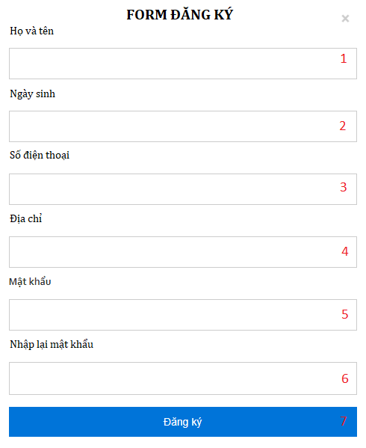

Figure 27 - Web Interface <Register account>

**Field**

|  |  |  |  |  |  |  |  |
| --- | --- | --- | --- | --- | --- | --- | --- |
| **No** | **Field Name** | **Description** | **Read only** | **Mandatory** | **Control Type** | **Data Type** | **Length** |
| 1 | Username | Patient’s information | No | Yes | Text | String |  |
| 2 | DateOfBirth | Patient’s information | No | Yes | Date | Date |  |
| 3 | Phone | Patient’s information | No | Yes | Text | String |  |
| 4 | Address | Patient’s information | No | Yes | Text | String |  |
| 5 | Password | Patient’s information | No | Yes | Password | String |  |
| 6 | PasswordConfirm | Patient’s information | No | Yes | Password | String |  |

**Buttons/Hyperlinks:**

|  |  |  |  |  |
| --- | --- | --- | --- | --- |
| **No** | **Function** | **Description** | **Validation** | **Outcome** |
| 7 | Register | Click to register | N/A | Navigate to Home page |

#### Nav Bar

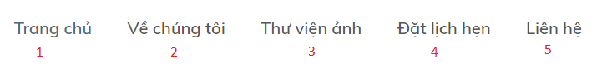

Figure 38 - Web Interface <Menu bar and Categories>

**Buttons/Hyperlinks:**

|  |  |  |  |  |
| --- | --- | --- | --- | --- |
| **No** | **Function** | **Description** | **Validation** | **Outcome** |
| 1 | Navigate to Home Page | N/A | N/A | Navigate to Home Page |
| 2 | Navigate to Introduction Page | Show list of categories as a drop down list | N/A | Navigate to Introduction Page |
| 3 | Navigate to Photo Library Page | N/A | N/A | Navigate to Photo Library Page |
| 4 | Navigate to Book Appointment Page | N/A | N/A | Navigate to Book Appointment Page |
| 5 | Navigate to Contact us | N/A | N/A | Navigate to Contact us |

#### Home Page

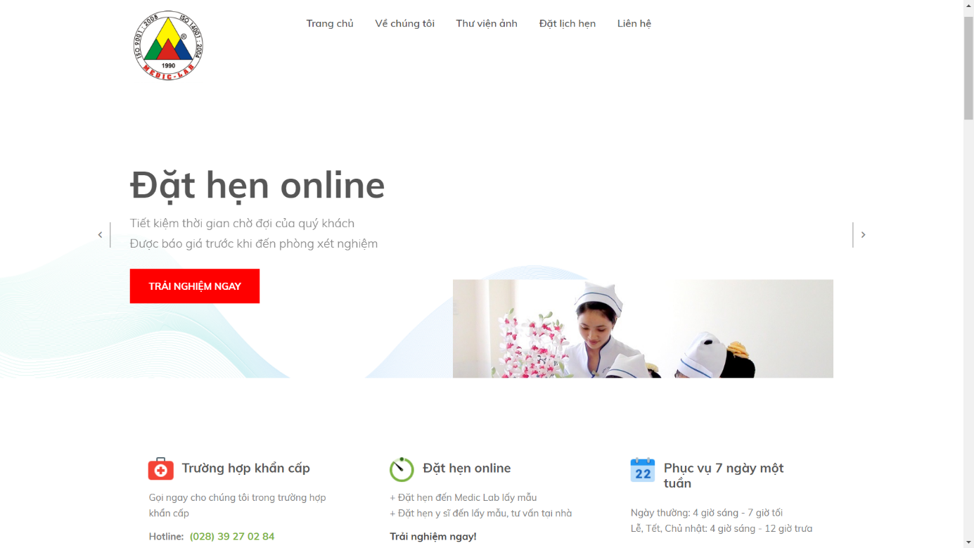

Figure 39 - Web Interface <Home page>

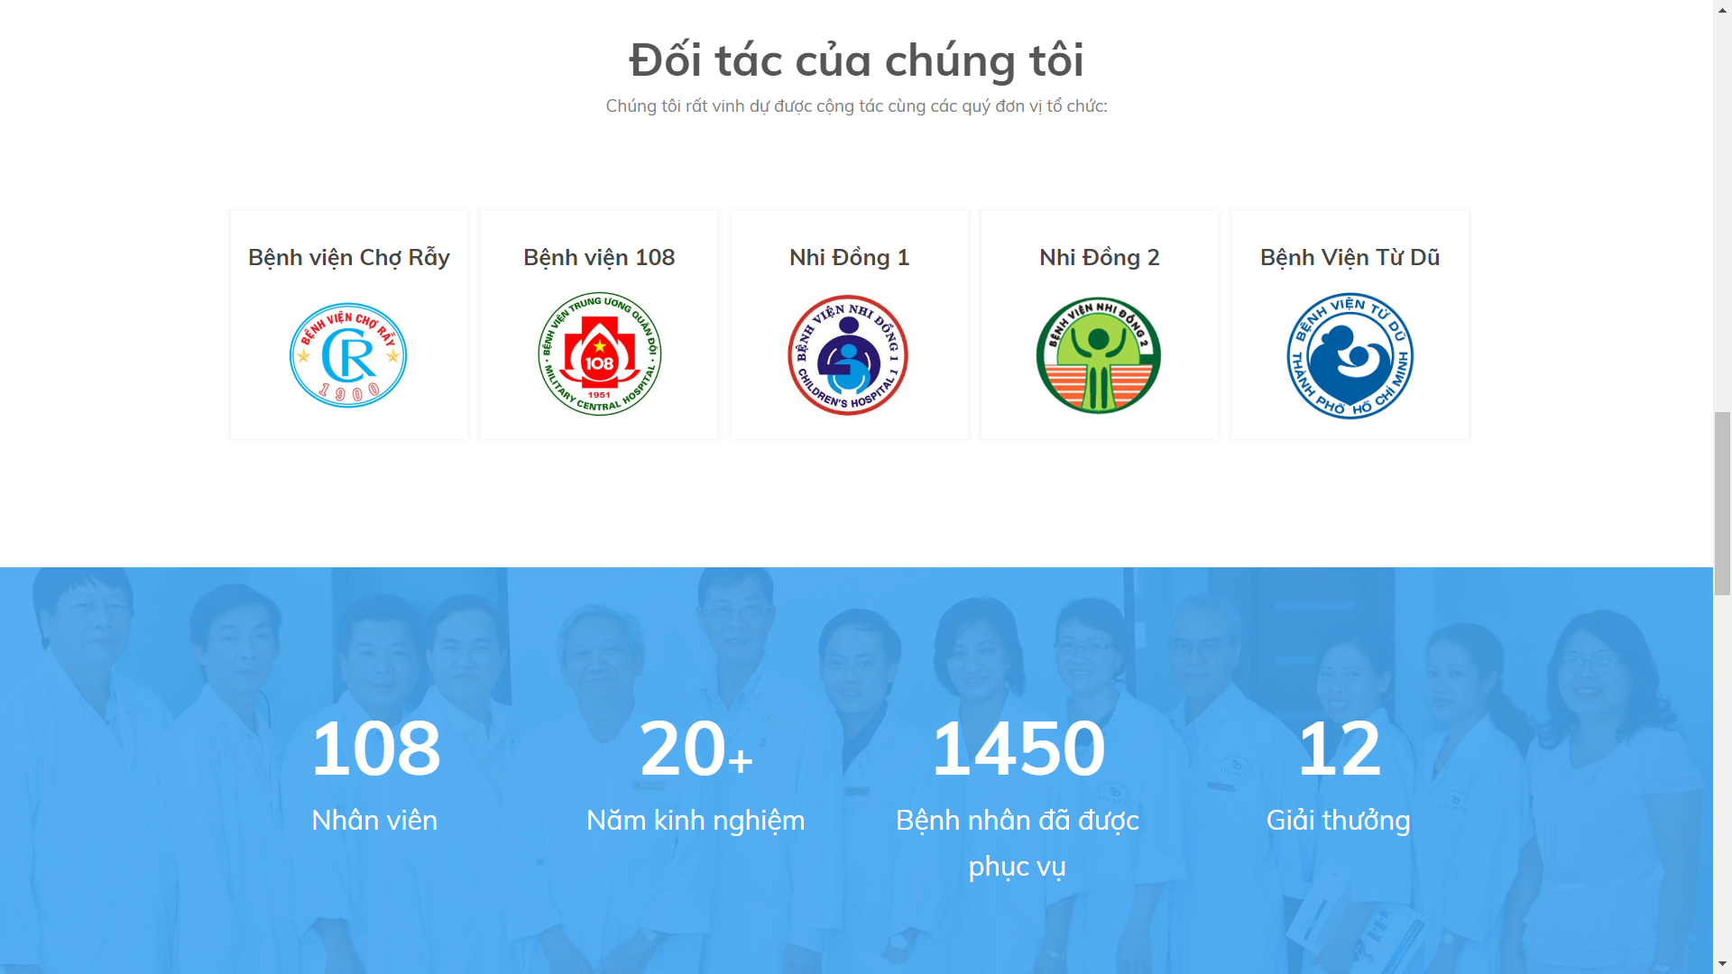

Figure 40 - Web Interface <Home page – Our partner>

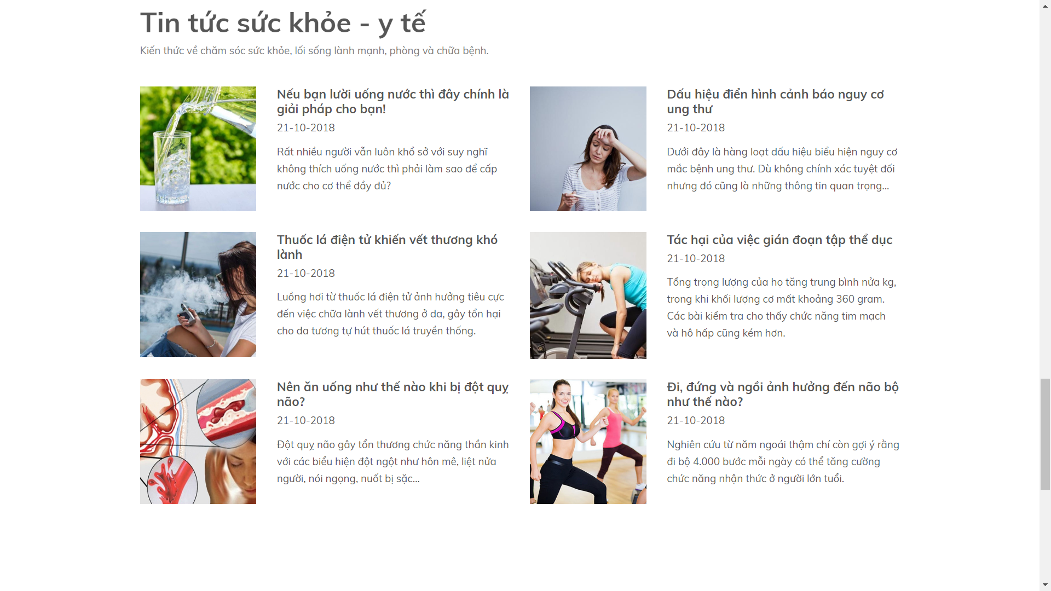

Figure 41 - Web Interface <Home page - News>

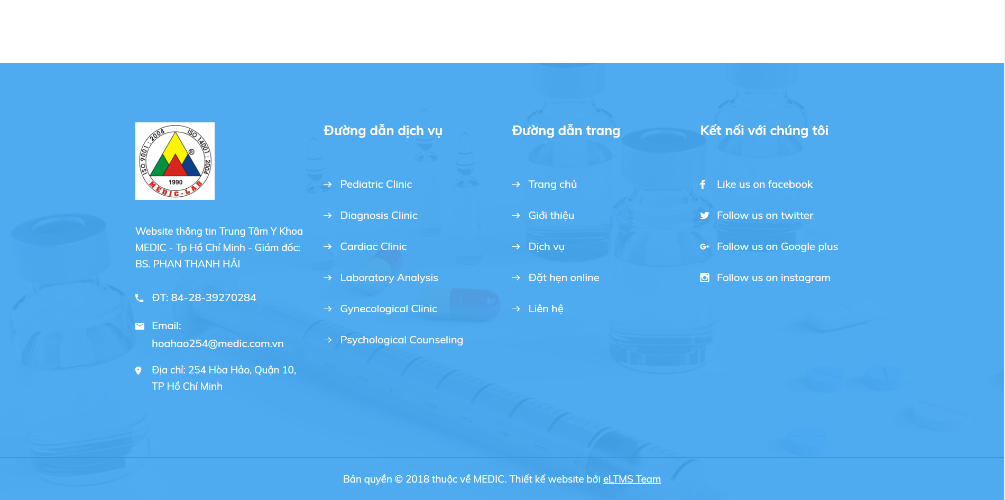

Figure 42 - Web Interface <Home page – Contact us >

#### Book Appointment

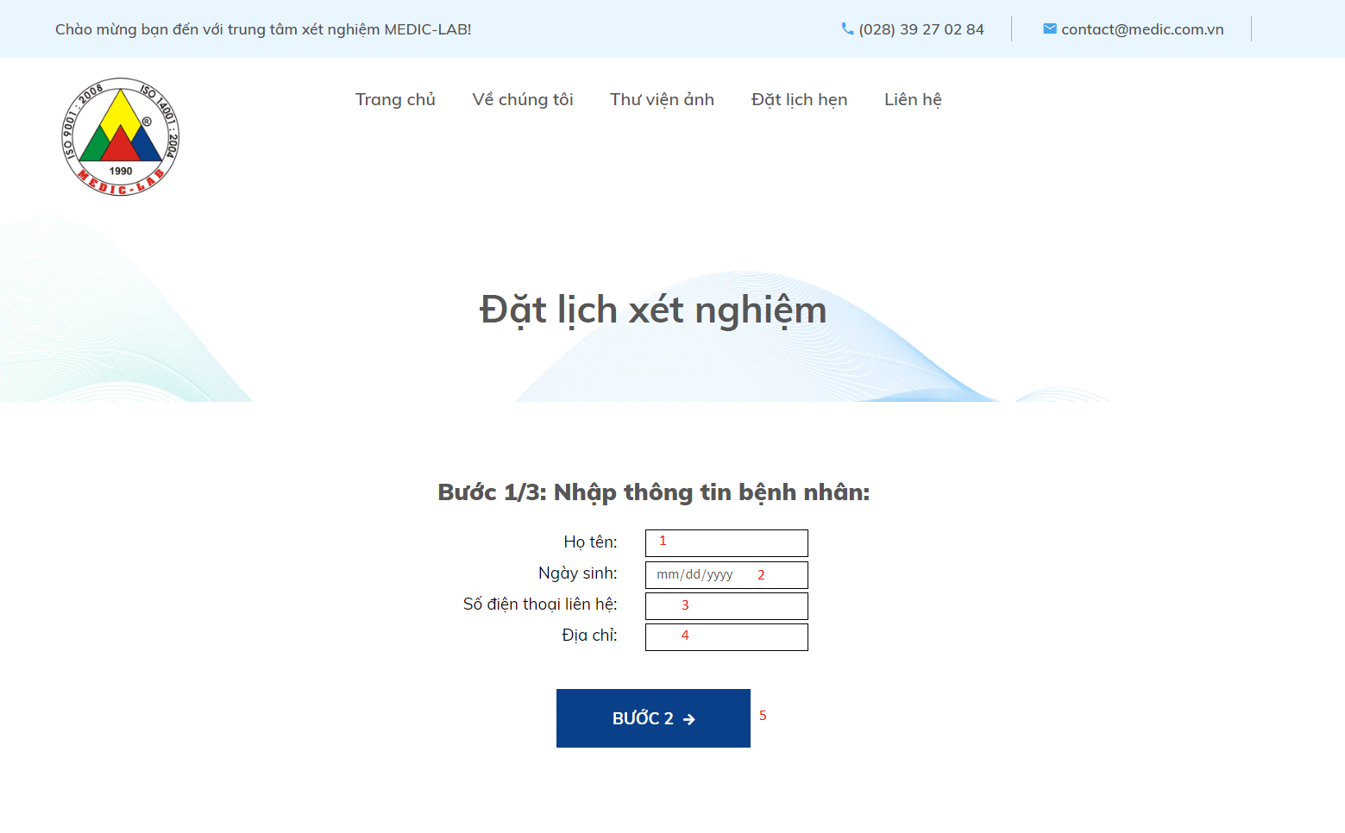

Figure 43 - Web Interface <Book Appointment>

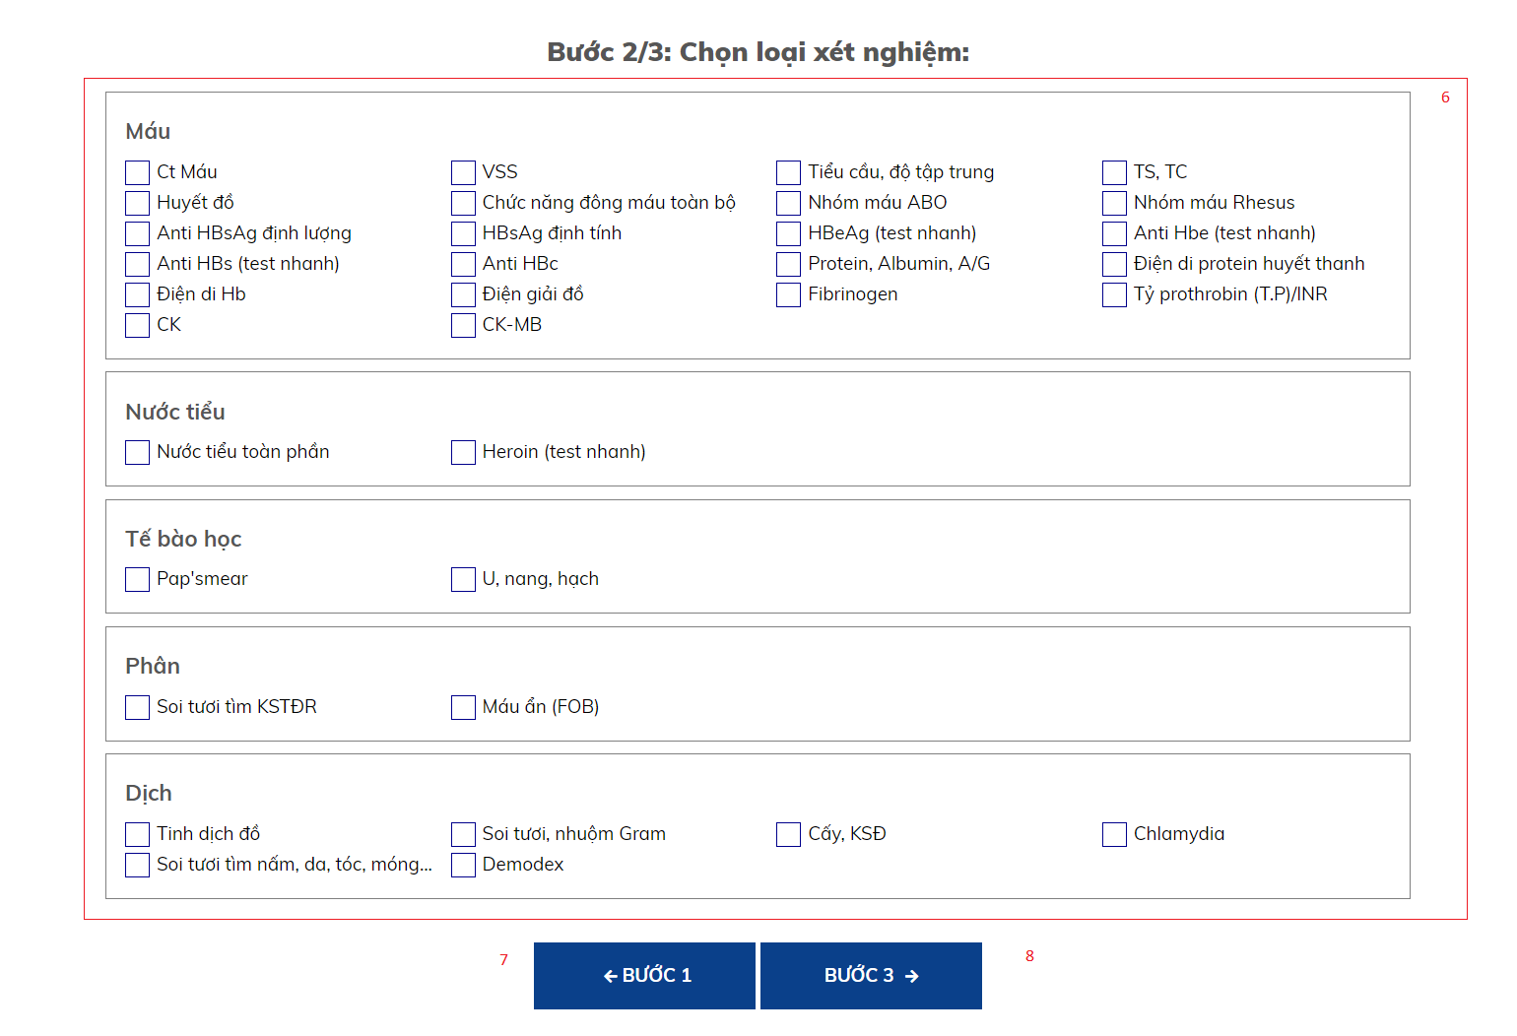

Figure 44 - Web Interface <Book Appointment>

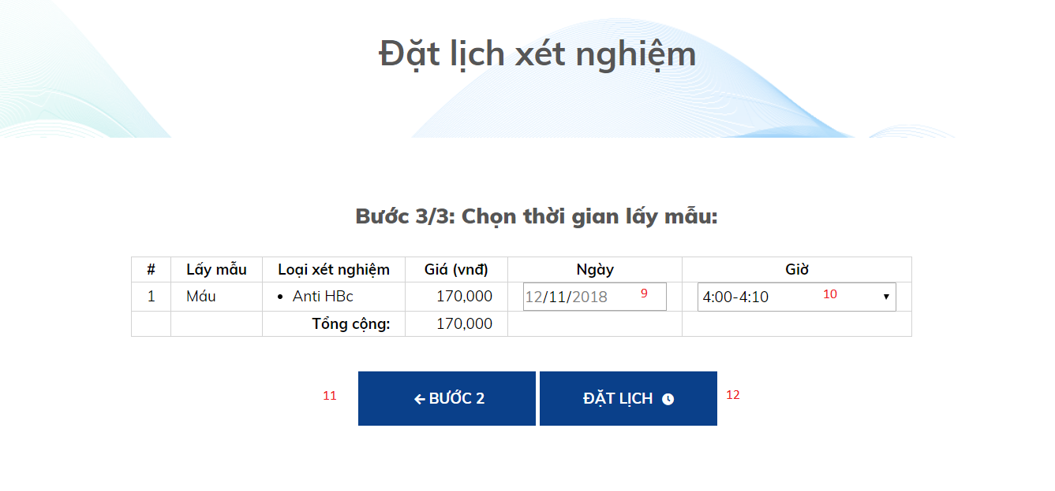

Figure 45 - Web Interface <Book Appointment>

**Field**

|  |  |  |  |  |  |  |  |
| --- | --- | --- | --- | --- | --- | --- | --- |
| **No** | **Field Name** | **Description** | **Read only** | **Mandatory** | **Control Type** | **Data Type** | **Length** |
| 1 | Họ và Tên | Patient’s information | No | Yes | Textbox | String |  |
| 2 | Ngày sinh | Patient’s information | No | Yes | Date | Date |  |
| 3 | Số điện thoại | Patient’s information | No | Yes | Textbox | String |  |
| 4 | Địa chỉ | Patient’s information | No | Yes | Textbox | String |  |
| 6 | Loại xét nghiệm | Choose labtest | No | Yes | Checkbox | Boolean |  |
| 9 | Ngày | Choose approriate time to test | No | Yes | Dropdown list | String |  |
| 10 | Giờ | Choose approriate time to test | No | Yes | Dropdown list | String |  |

**Buttons/Hyperlinks**

|  |  |  |  |  |
| --- | --- | --- | --- | --- |
| **No** | **Function** | **Description** | **Validation** | **Outcome** |
| 5 | Go to step 2 | Click “Bước 2” to go to step 2 | Validate all required fields | Go to step 2 |
| 7 | Go back to step 1 | Click “Bước 1” to go back to step 1 | N/A | Go back to step 1 |
| 8 | Go to step 3 | Click “Bước 3” to go to step 3 | Choose a least one labtest | Go to step 3 |
| 11 | Go back to step 2 | Click “Bước 2” to go back to step 2 | N/A | Go back to step 2 |
| 12 | Submit | Complete booking a new appointment | Validate all required fields | Booking successfully |

#### View list of Booked Appoinments



Figure 46 - Web Interface <View list of booked Appointments>

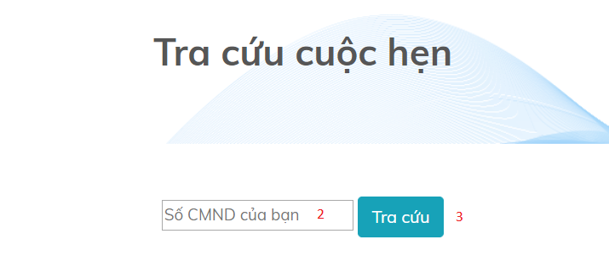

Figure 47 - Web Interface <View list of booked Appointments>

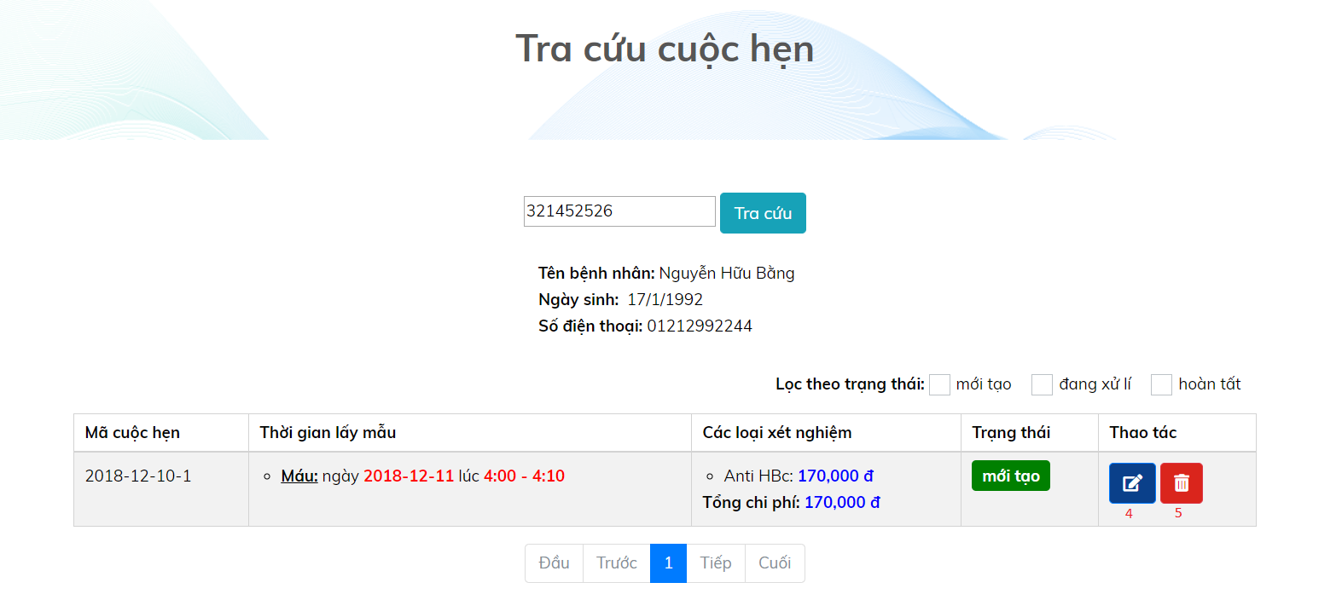

Figure 48 - Web Interface <View list of booked Appointments>

**Field**

|  |  |  |  |  |  |  |  |
| --- | --- | --- | --- | --- | --- | --- | --- |
| **No** | **Field Name** | **Description** | **Read only** | **Mandatory** | **Control Type** | **Data Type** | **Length** |
| 2 | CMND | Input id into textbox area | No | No | Text | String |  |

**Buttons/Hyperlinks**

|  |  |  |  |  |
| --- | --- | --- | --- | --- |
| **No** | **Function** | **Description** | **Validation** | **Outcome** |
| 1 | Navigate to Auctions by View Appointment Page | When user clicks on the link, navigate to a page showing textbox to fill id | N/A | Navigate to a page show textbox to fill id of patient |
| 3 | Search | Click “Tra cứu” to get result from system | N/A | Go to View Appointment Page |
| 4 | Edit appointment | Edit time, sample, labtest for appointment | N/A | Patient’s appointment will be updated |
| 5 | Delete appointment | Delete appointment | N/A | Appointment is deleted |

Figure 36 - Web Interface < Categories bar and sort>

#### View Testing Result

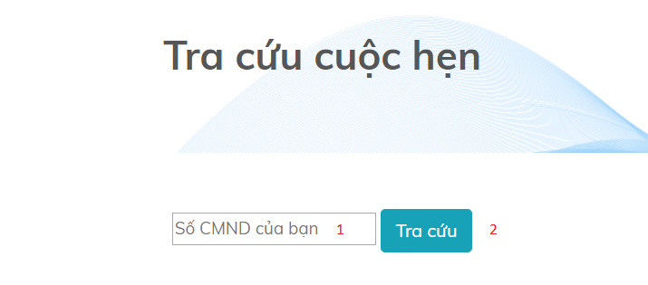

Figure 49 - Web Interface <View Testing Result>

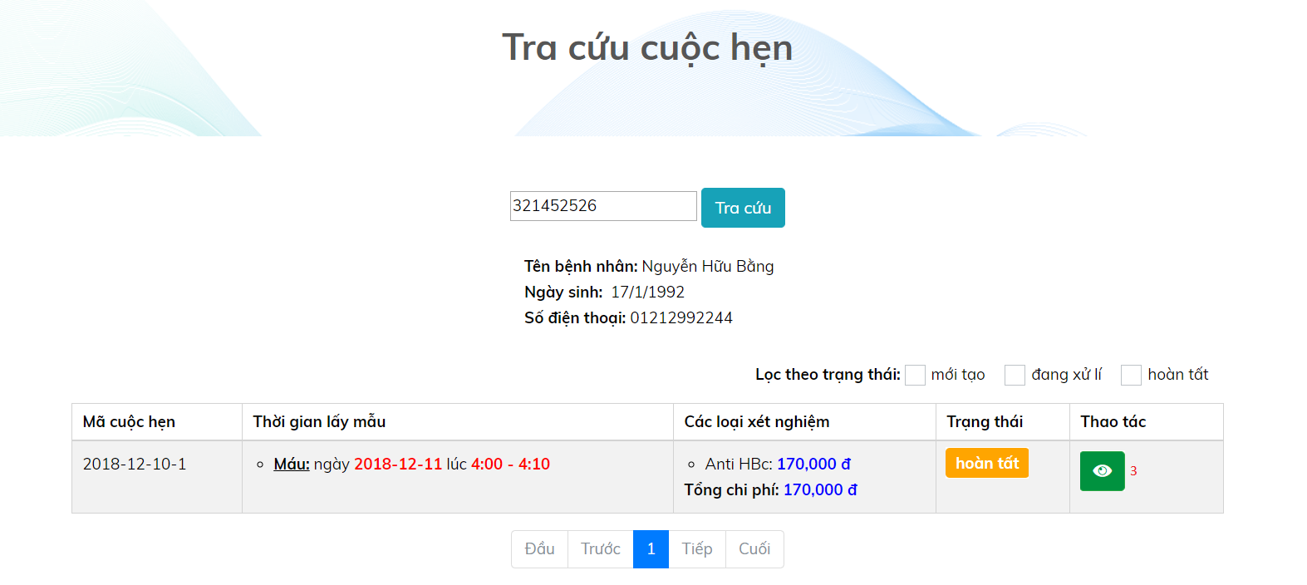

Figure 50 - Web Interface <View Testing Result>

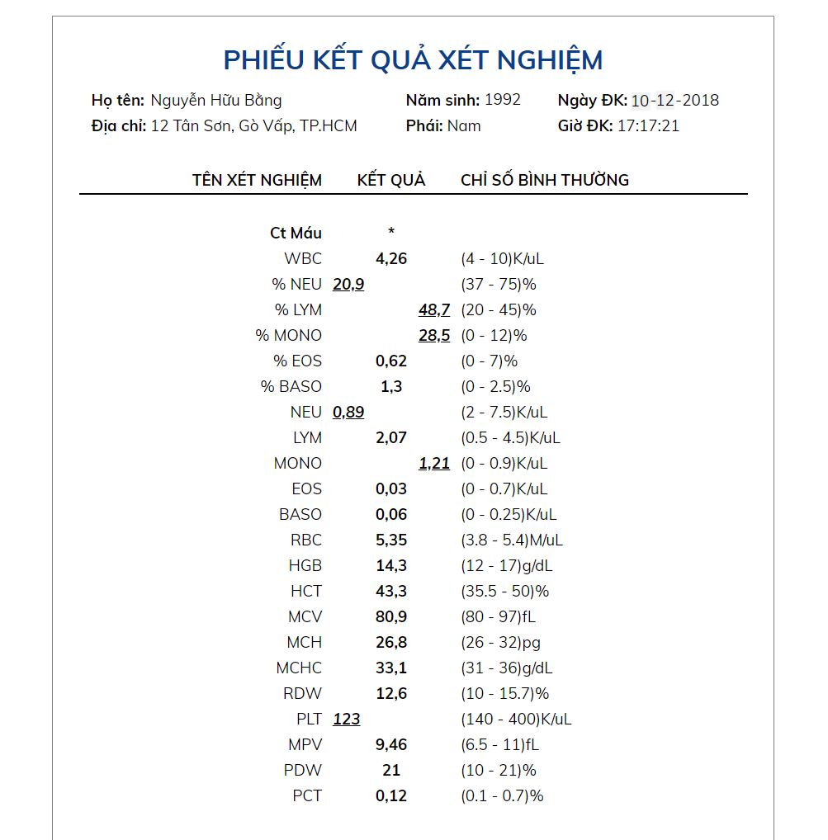

Figure 51 - Web Interface <View Testing Result>

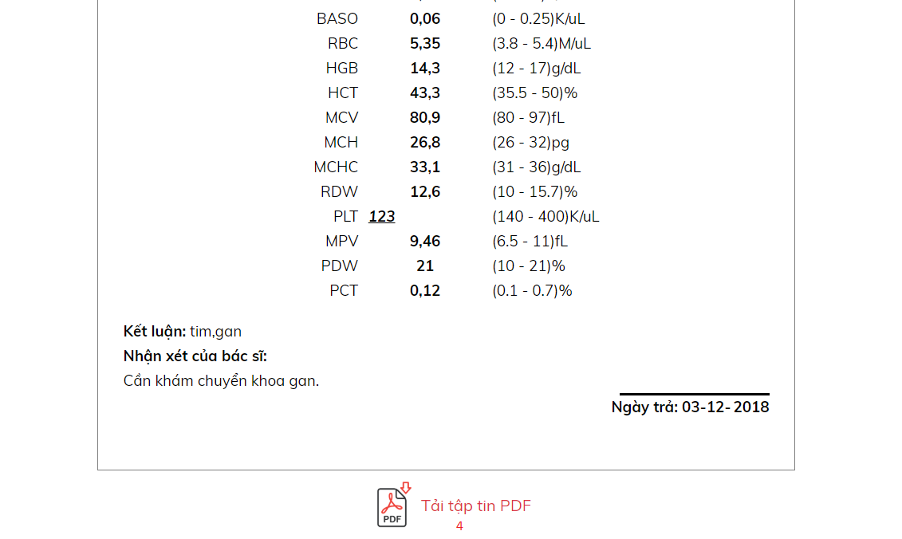

Figure 52 - Web Interface <View Testing Result>

**Field**

|  |  |  |  |  |  |  |  |
| --- | --- | --- | --- | --- | --- | --- | --- |
| **No** | **Field Name** | **Description** | **Read only** | **Mandatory** | **Control Type** | **Data Type** | **Length** |
| 1 | CMND | Input id into textbox area | No | No | Text | String |  |

**Buttons/Hyperlinks**

|  |  |  |  |  |
| --- | --- | --- | --- | --- |
| **No** | **Function** | **Description** | **Validation** | **Outcome** |
| 2 | Search | Click “Tra cứu” to get result from system | N/A | Go to View Appointment Page |
| 3 | View testing result | View testing result | N/A | Go to Result Appointment Page |
| 4 | Download testing result | User can download testing result file as pdf file | N/A | Testing result file will be downloaded |

### Mobile application user interface

#### Login page

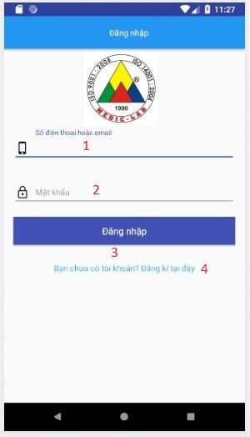

Figure 53 - Mobile Interface <Login>

**Field**

|  |  |  |  |  |  |  |  |
| --- | --- | --- | --- | --- | --- | --- | --- |
| **No** | **Field Name** | **Description** | **Read only** | **Mandatory** | **Control Type** | **Data Type** | **Length** |
| 1 | Phone | Phone to login | No | Yes | Textbox | String |  |
| 2 | Password | Password to login | No | Yes | Textbox | String |  |

**Buttons/Hyperlinks:**

|  |  |  |  |  |
| --- | --- | --- | --- | --- |
| **No** | **Function** | **Description** | **Validation** | **Outcome** |
| 3 | Sign In | Login into system | Validate all required fields | Navigate to Home page |
| 4 | Navigate to Register Page | N/A | N/A | Navigate to Register Page |

#### Register Account page

Figure 55 - Mobile Interface <Register account>

**Field**

|  |  |  |  |  |  |  |  |
| --- | --- | --- | --- | --- | --- | --- | --- |
| **No** | **Field Name** | **Description** | **Read only** | **Mandatory** | **Control Type** | **Data Type** | **Length** |
| 1 | Username | Username to register | No | Yes | Textbox | String |  |
| 2 | Phone | Phone to register | No | Yes | Textbox | String |  |
| 3 | Email | Email to register | No | Yes | Textbox | String |  |
| 4 | Full name | Fullname to register | No | Yes | Textbox | String |  |
| 5 | Date of Birth | D.O.B to register | No | Yes | Datepicker | Date |  |
| 6 | Password | Password to register | No | Yes | Textbox | String |  |
| 7 | Re-Password | Re-Password to confirm password | No | Yes | Textbox | String |  |

**Buttons/Hyperlinks:**

|  |  |  |  |  |
| --- | --- | --- | --- | --- |
| **No** | **Function** | **Description** | **Validation** | **Outcome** |
| 8 | Register | Register into system | Validate all required fields | Navigate to Phone verify page, then navigate to Login Page |
| 9 | Navigate to Login Page | N/A | N/A | Navigate to Login Page |

## **Database Design**

### Entity relationship diagram (ERD)

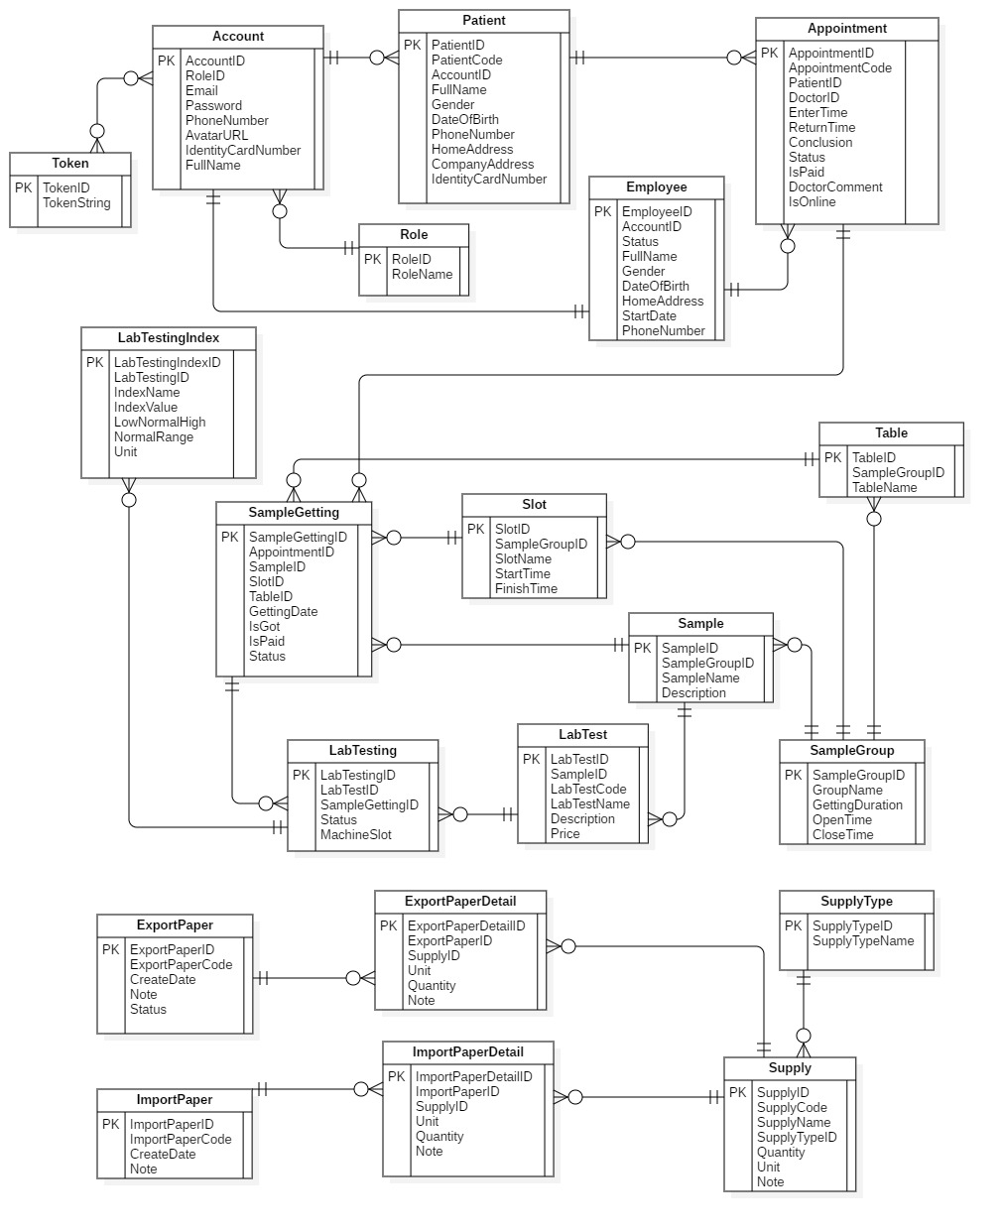

Figure 67 - Entity relationship diagram (ERD)

### Entity dictionary

|  |  |
| --- | --- |
| Entity Data Dictionary: describe content of all entities | |
| **Entity name** | **Description** |
| User | Contains the user information |
| Admin | Contains the admin information |
| Personal Member | Contains the personal member (auctioneer, bidder) information |
| Role | Contains the role information |
| UserRole | Contain the user’s roles information |
| Address | Contain the address roles information |
| Item | Contains the item information |
| Auction | Contains the auction information |
| Category | Contains the category information |
| Media | Contains the media information |
| Bid | Contains the bid information |
| MinIncrementRule | Contains the minimum increment rule information (for calculating minimum bid that bidder has to place on an item). |

Table 14 - Entity dictionary

## **Algorithms**

### Slot Suggestion

#### Definition

Generate the set of samples getting slots which has minimum total time.

#### Define problem

- When create a new appointment, user often have to spend a lot of effort to choose the suitable slots. Then, there is a need for an automatic solution using algorithms.

- There are N sample-gettings that the patient needs to perform. (blood getting, urine getting, are sample-gettings)

- Each room has a set of slots which have the same durations. Different sample getting rooms can have different slot durations.

- Assume that patients need to do all sample-gettings that they chosed in ONE day, so that the total time is minimum.

#### Solution

We use permutation recursive permutation and dynamic programming (DP) to solve this problem. We follow 2 steps:

* Step 1: Consider each permutation of N sample getting rooms in order, we use DP to calculate the optimized set of slots in the order of sample-gettings.
* Step 2: DP Formula:
* Assume that T[i][j].StartTime: the start time of the j-slot in the i-th slot set. (the i-th slot set belongs to the i-th sample getting).
* Assume that T[i][j].FinishTime: the finish time.
* Assume that dp[i][j] is the minimum waiting time (between slots of sample gettings) if the last sample-getting is the i-th one and the it’s chosed slot is the j-th slot. i is from 0 to N-1, j is from 0 to Length of i-th slot set – 1. Because the sample-gettings’ duration is fixed, the order, which has the minimum waiting time, has the minimum total time.
* dp[i][j] = min {dp[i-1][k] + (T[i-1][k].StartTime – T[i][j].FinishTime) | T[i-1][k].StartTime – T[i][j].FinishTime > 0}.
* Base: dp[0][j] = T[0][j] – comingTime. (comingTime: the time that the patient arrives at the hospital).
* The result of problem is min {dp[n-1][j]}.
* Step 3: Trace to get the optimized order of slots.

#### Complexity

The complexity of this algorithm is **O(N! * N3). In which, N is the number of selected Samples of a patient on a day.**

#### C:\Users\Duc\AppData\Local\Microsoft\Windows\INetCache\Content.Word\eLTMS-DP.PNGFlowchart